**Appendix A: Gantt Chart**

*Figure 6.1:*

**Appendix B: PERT Diagram**

*Figure 6.2:*

**Appendix C: Entity Relationship Diagram**

*Figure 6.3:*

**Appendix D: User’s Manual**

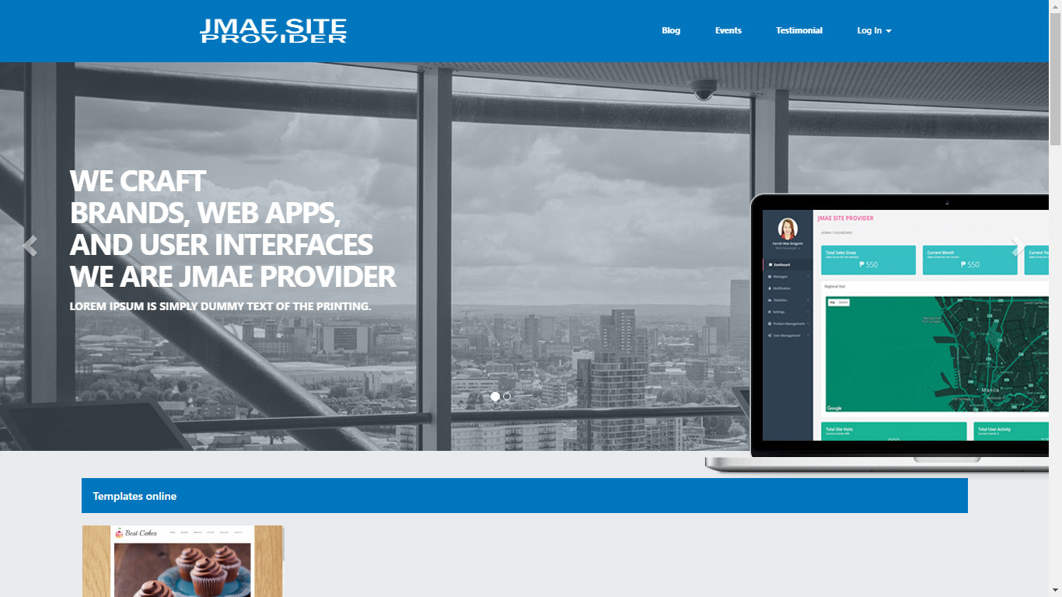

*Figure 6.4: Homepage*

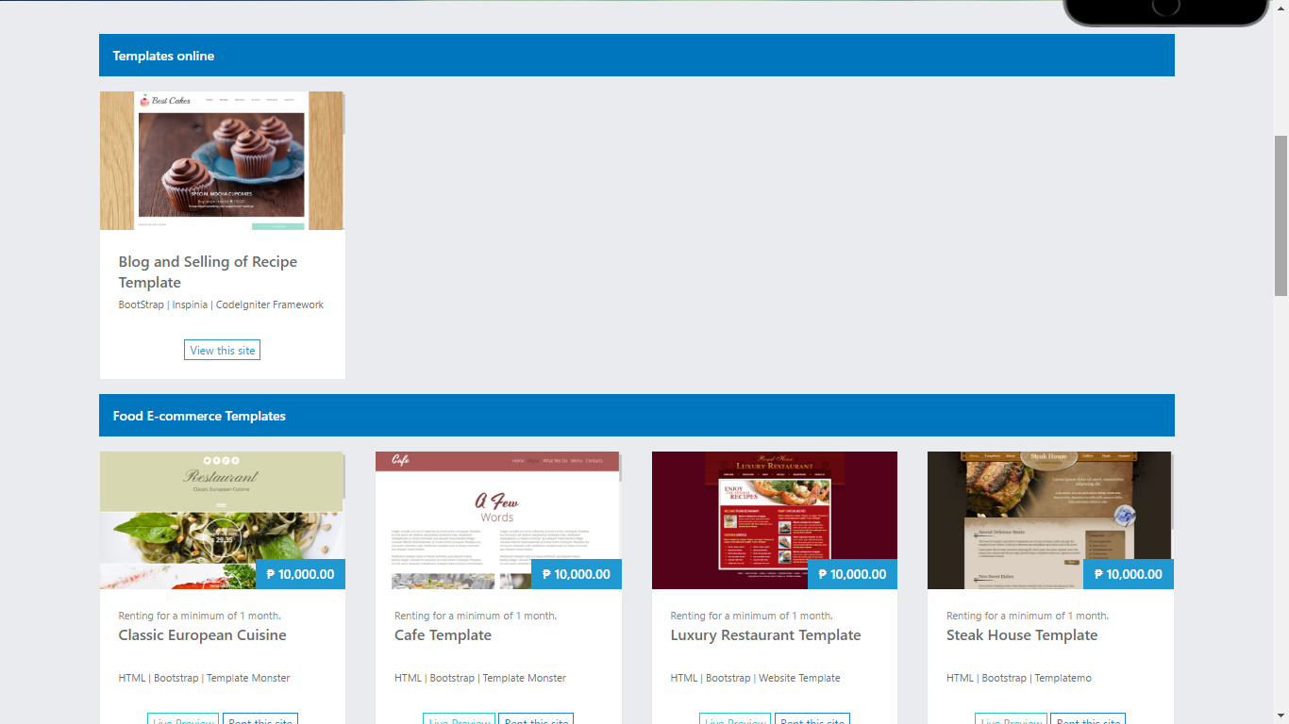

*Figure 6.5: Homepage*

* When you open our website, this page will show on your screen.
* In the navigation, which is located at the top, there are four (4) categories: Blog, Events, Testimonials, and Log In.
* In the home page, there are two (2) modules: The Templates Rented and the Food E-commerce Templates. In the Templates Rented, all the templates listed are already rented by the client. In the Food E-commerce Templates, all the list of templates that are available for renting at allotted time.

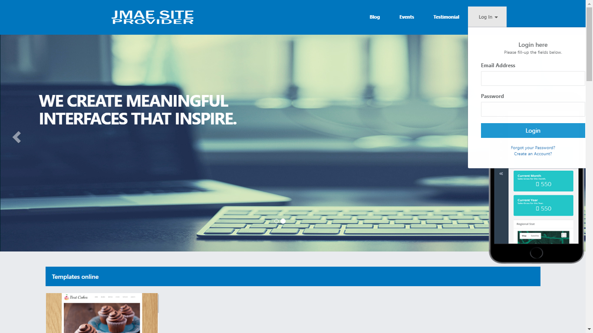

*Figure 6.6: Login Form*

* You are allowing to access on this website if you have an existing account, if not just click the Create an Account? at the below of the Forgot your Password?.

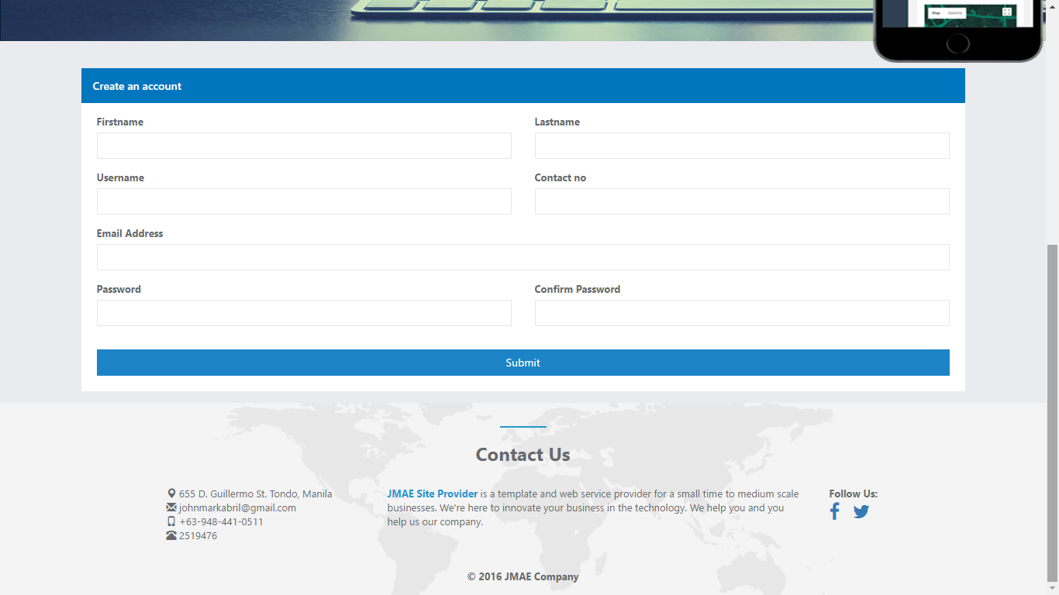

*Figure 6.7: Create an Account*

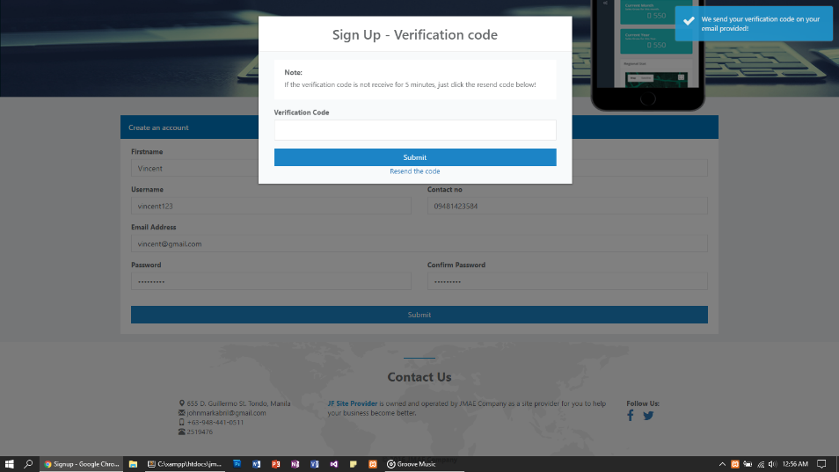

*Figure 6.8: Create an Account*

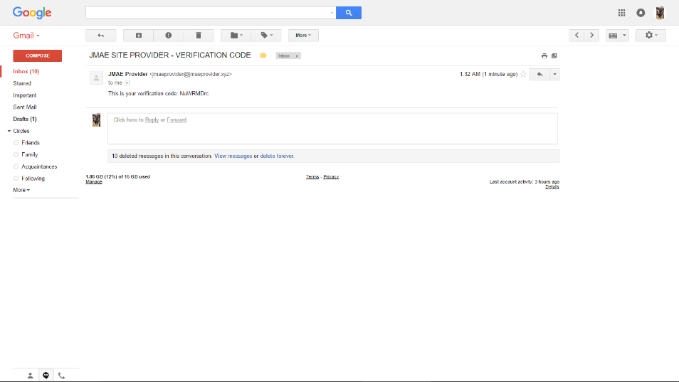

*Figure 6.9: Create an Account*

* You can create your account if you haven’t yet already. It has an e-mail verification for you to determine if you’re a bot or not.

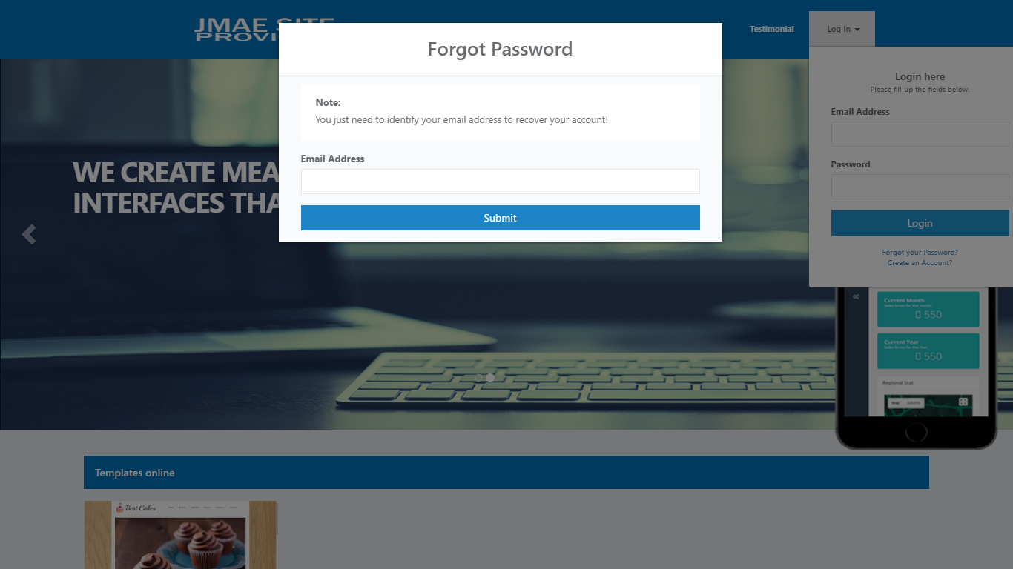

*Figure 6.10: Forgot Password*

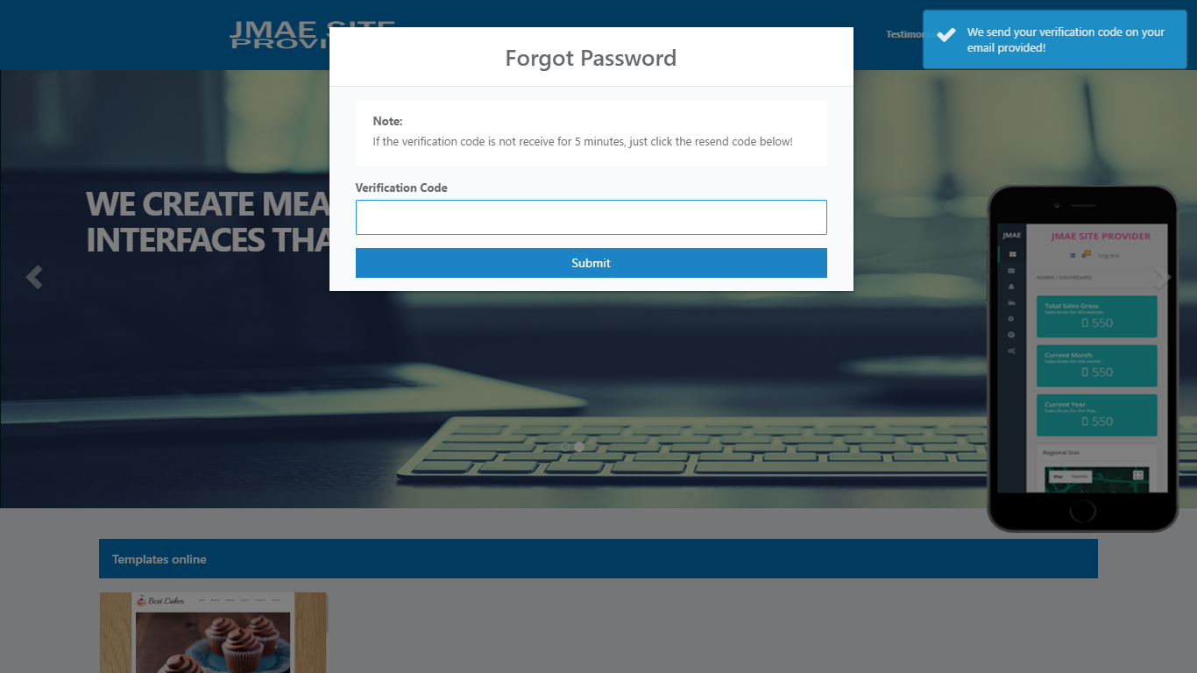

*Figure 6.11: Forgot Password*

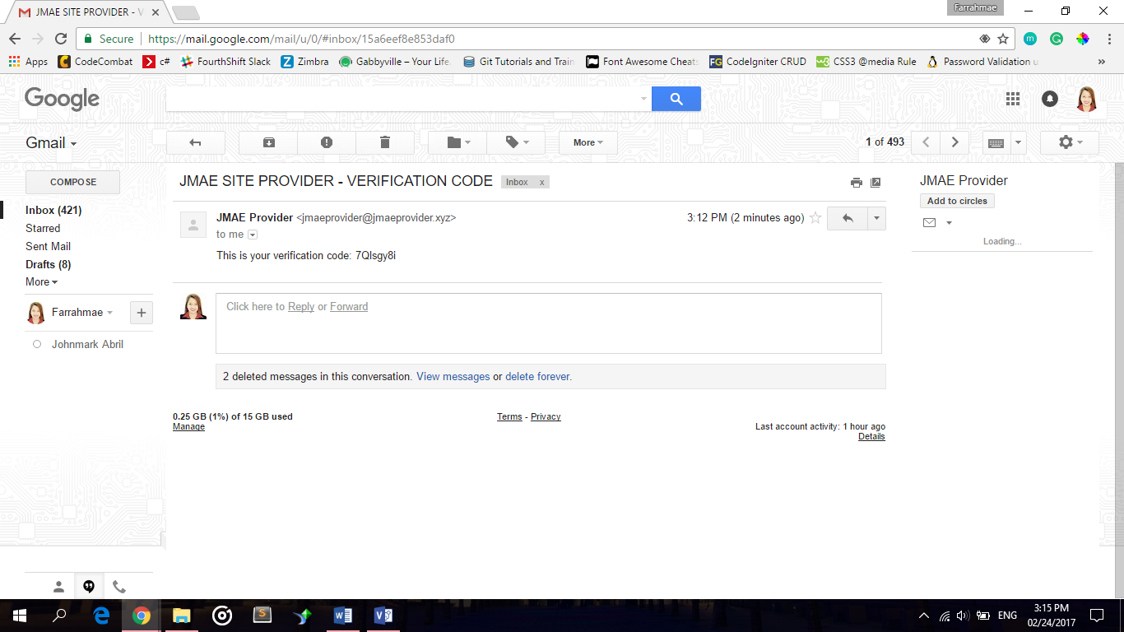

*Figure 6.12: Forgot Password*

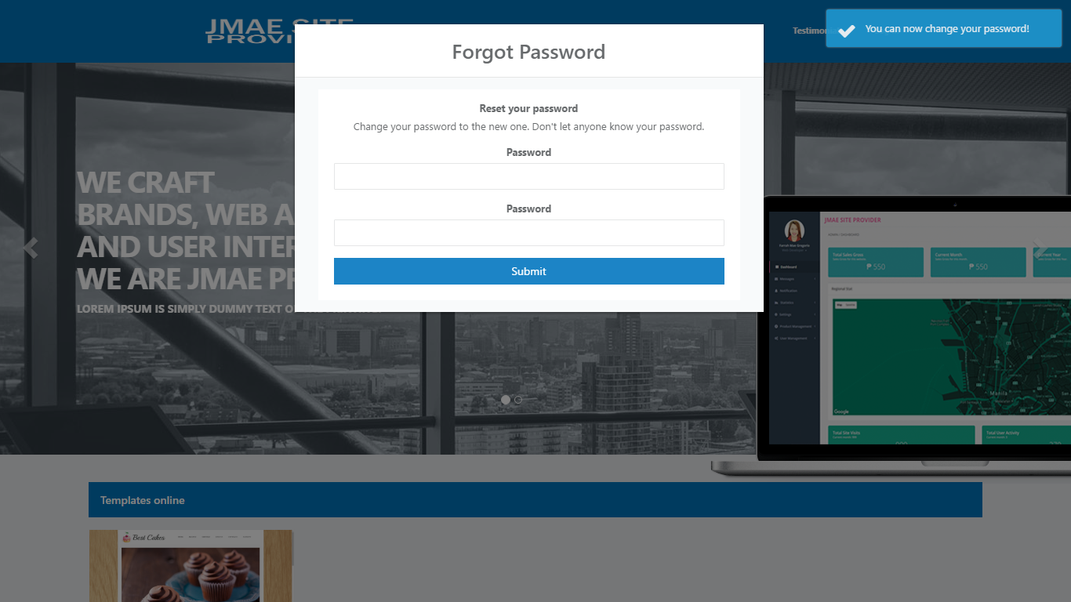

*Figure 6.13: Forgot Password*

* If you forgot your password, just simply click Forgot your Password? at the below of Login button.
* Just simply input your e-mail, and you can receive a verification code.
* Copy and paste the verification you received and you can create now your new password.

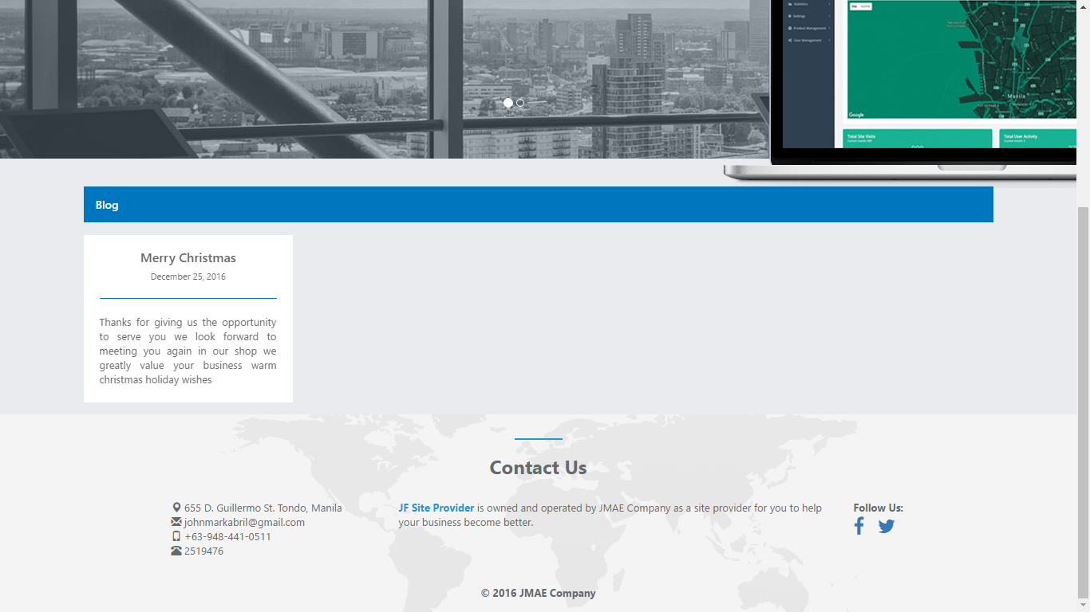

*Figure 6.14: Blog*

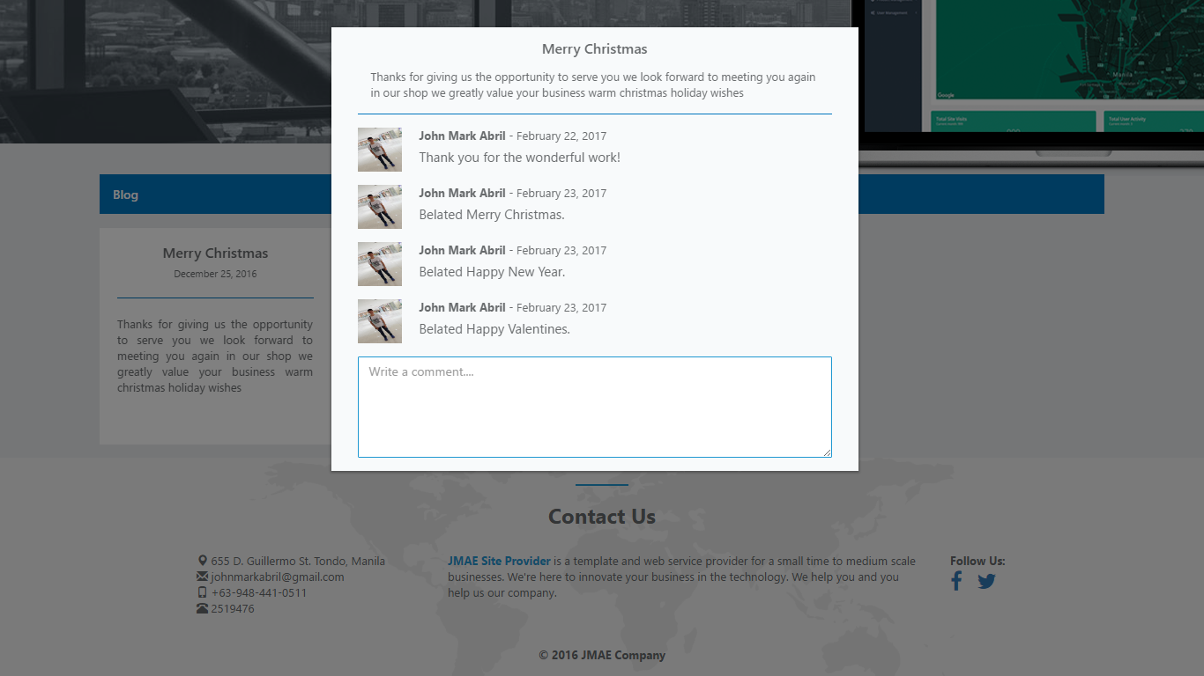

*Figure 6.15: Blog*

* In Blog, you can browse the thoughts of the administrator and you can respond to it if you already login your account.

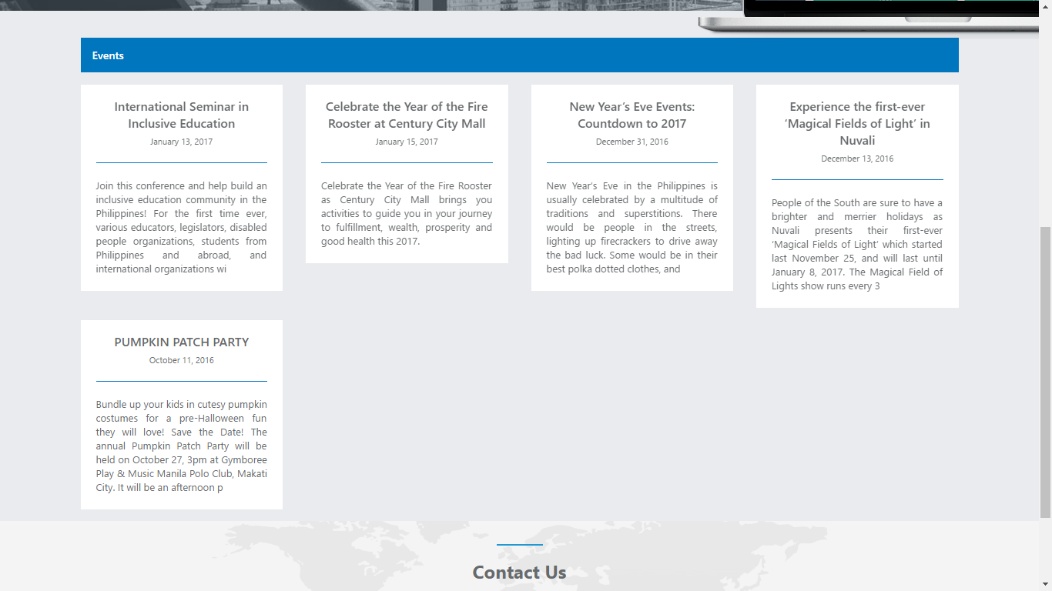

*Figure 6.16: Events*

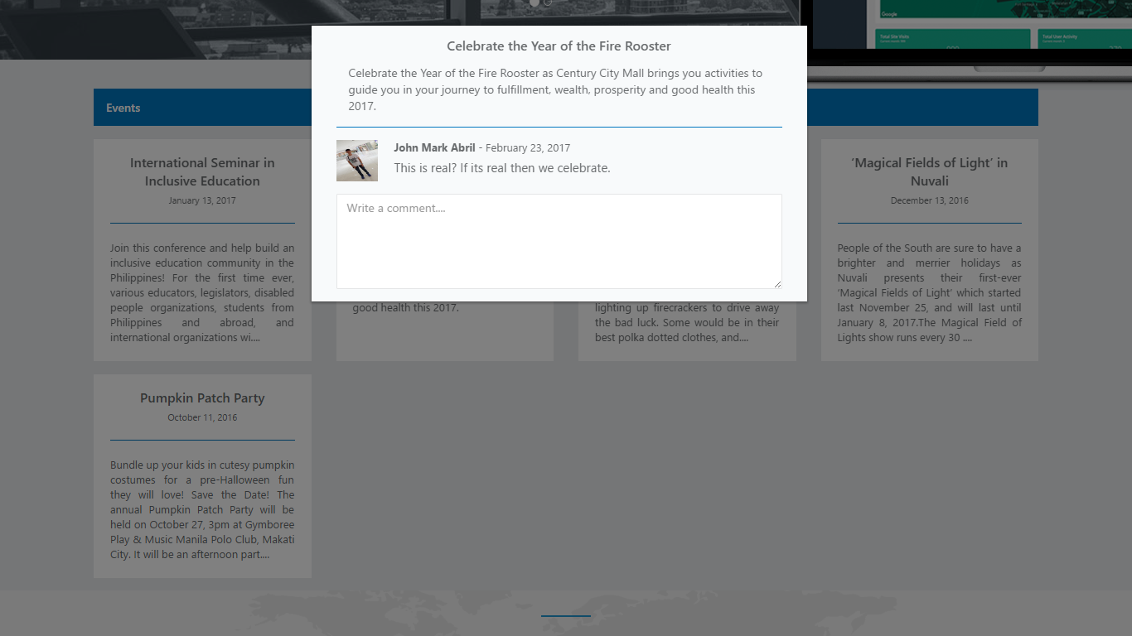

*Figure 6.17: Events*

* In Events, you can browse the upcoming events or announcement posted by the administrator, it is the same at the blog you can respond to it if you already login your account.

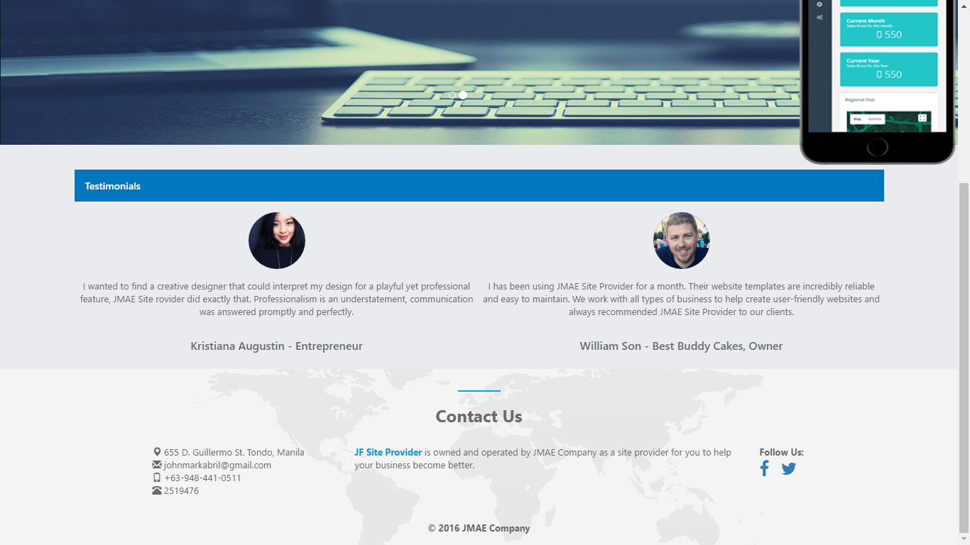

*Figure 6.18: Testimonials*

* In Testimonials, you can browse the feedback of the client of their purchased template and to the service of the JMAE Site Provider.

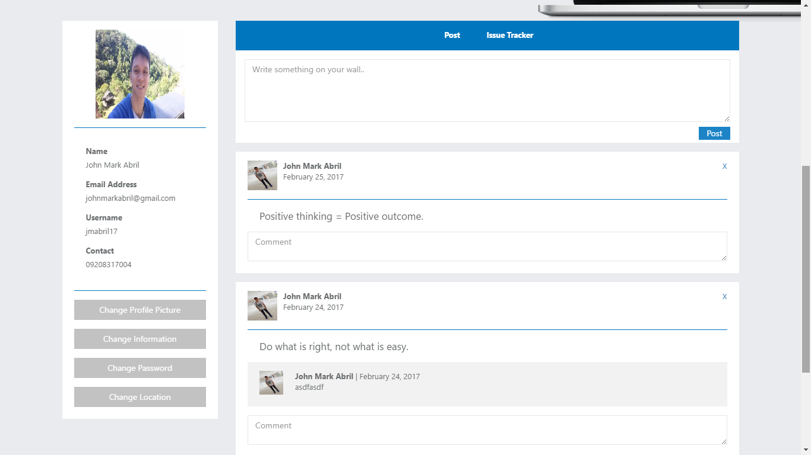

*Figure 6.19: Profile*

* If you already log in as user, you can see the additional categories on your navigation top which is the Profile.
* In Profile, you can see some information like: Name, Email Address, Username and Contact.
*     these are the buttons if you want to update your personal information.
* Also, you have a mini social media for you not to be bored, you may also see the other post of user and you can make a respond to it.
* In your Issue Tracker tab, you can make a conversation with the administrator if you have any bug of your purchased template.

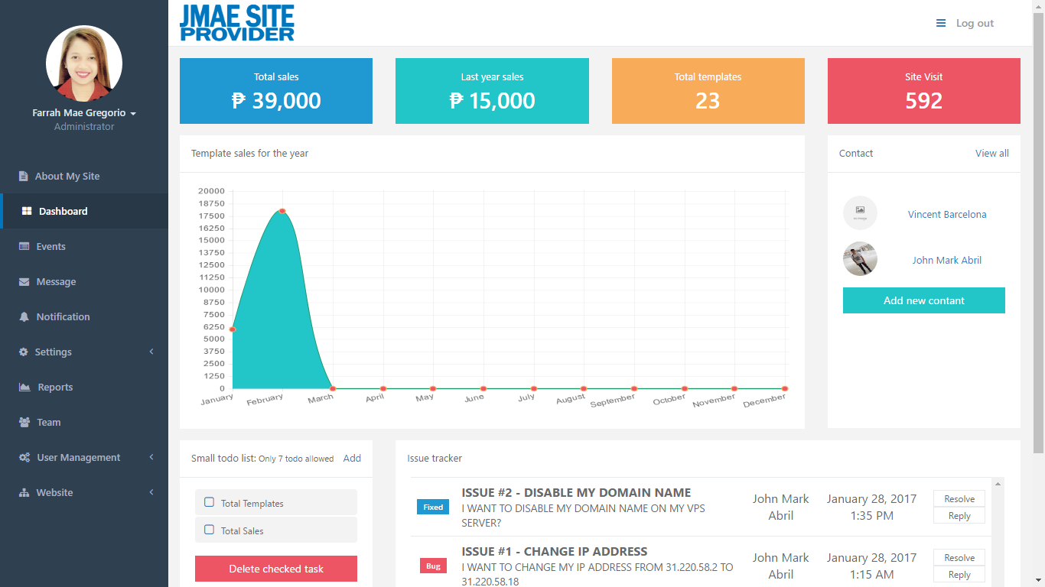

*Figure 6.20: Administrator – Dashboard*

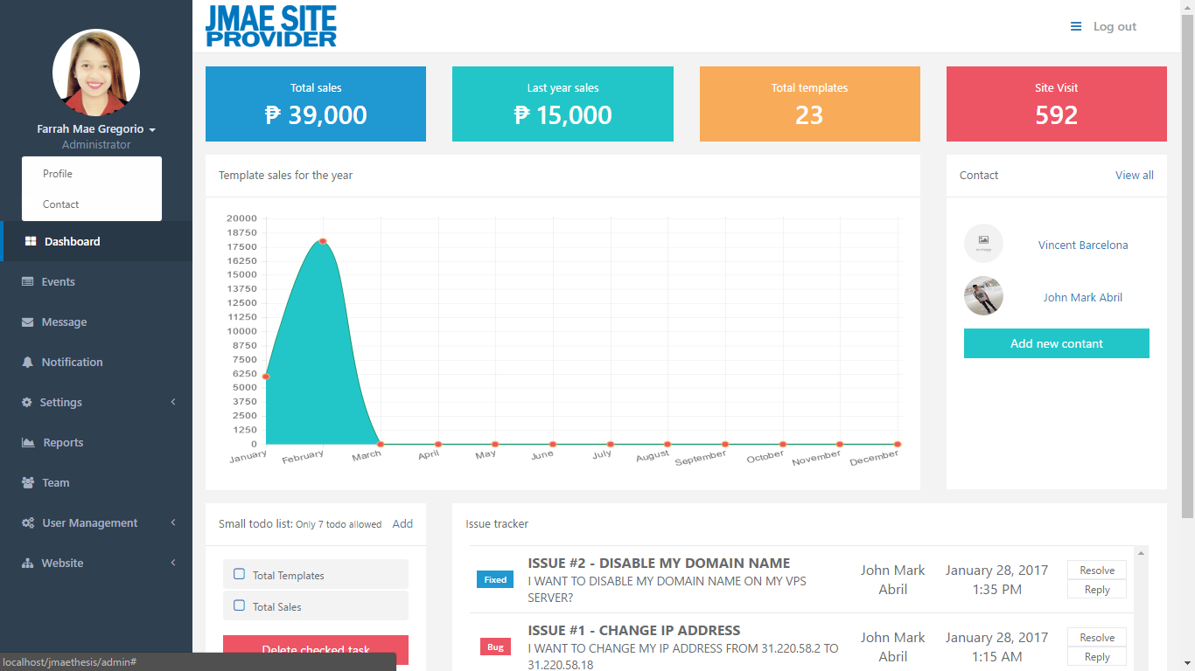

*Figure 6.21: Administrator – Dashboard*

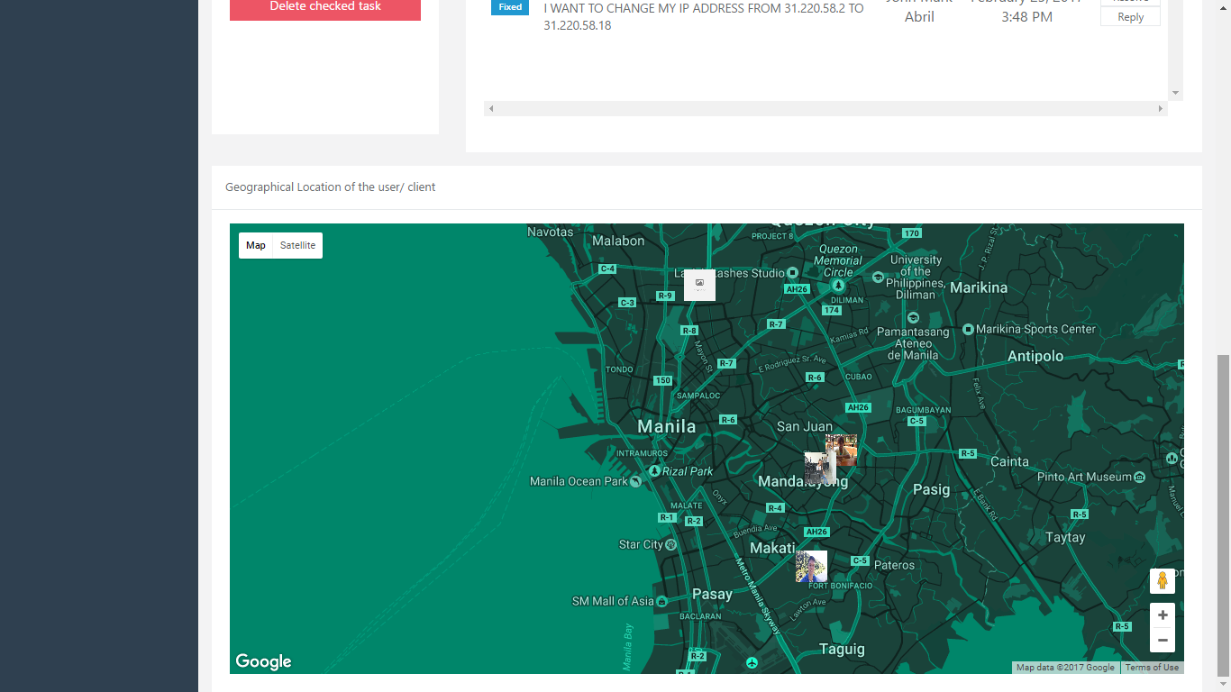

*Figure 6.22: Administrator – Dashboard*

* If you log in as administrator, you can see in your navigation on the left side, there are twelve (12) categories: The Profile, Contact, About My Site, Dashboard, Events, Message, Notification, Settings, Reports, Team, User Management, and Website.
* The first category is the Dashboard. It contains the report of Total Sales of the current year, Last Year Sales, Total Templates, Site Visit, Template sales of the year, Contact, Small todo list, and the Issue Tracker.
* The Small todo List is a simple reminder to you of what task you’re going to accomplish.
* The Issue Tracker you can make a conversation with the client who sends a message about of the issue or question in his/her purchased template.
* The Geographical Location of the user/ client you can easy to find where the user/client located.

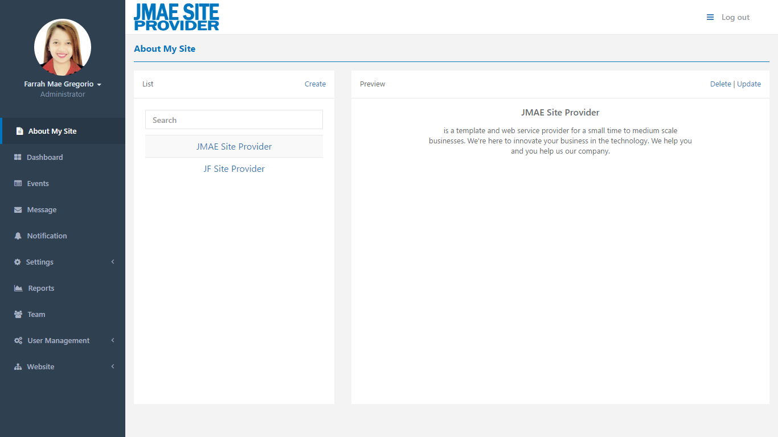

*Figure 6.23: Administrator – About My Site*

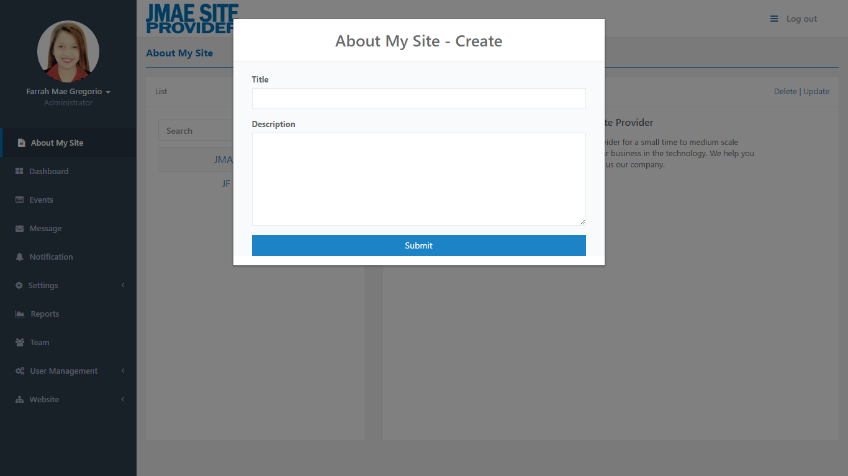

*Figure 6.24: Administrator – About My Site*

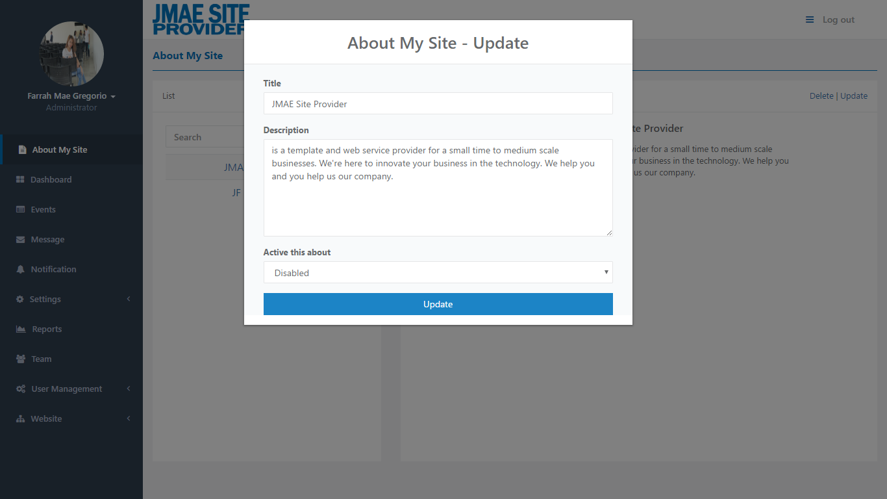

*Figure 6.25: Administrator – About My Site*

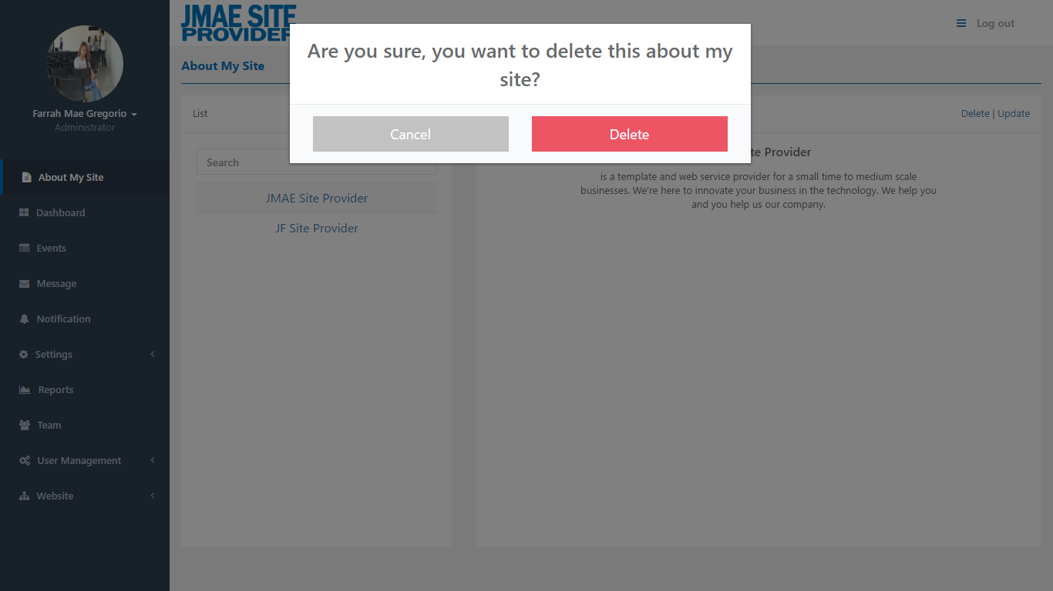

*Figure 6.26: Administrator – About My Site*

* In About My Site, you can choose to the list which is you’re going to enable for the content of your About My Site that located to the footer or lower part on the website by clicking Update.
* Also, you can update and delete the content of the selected About My Site.

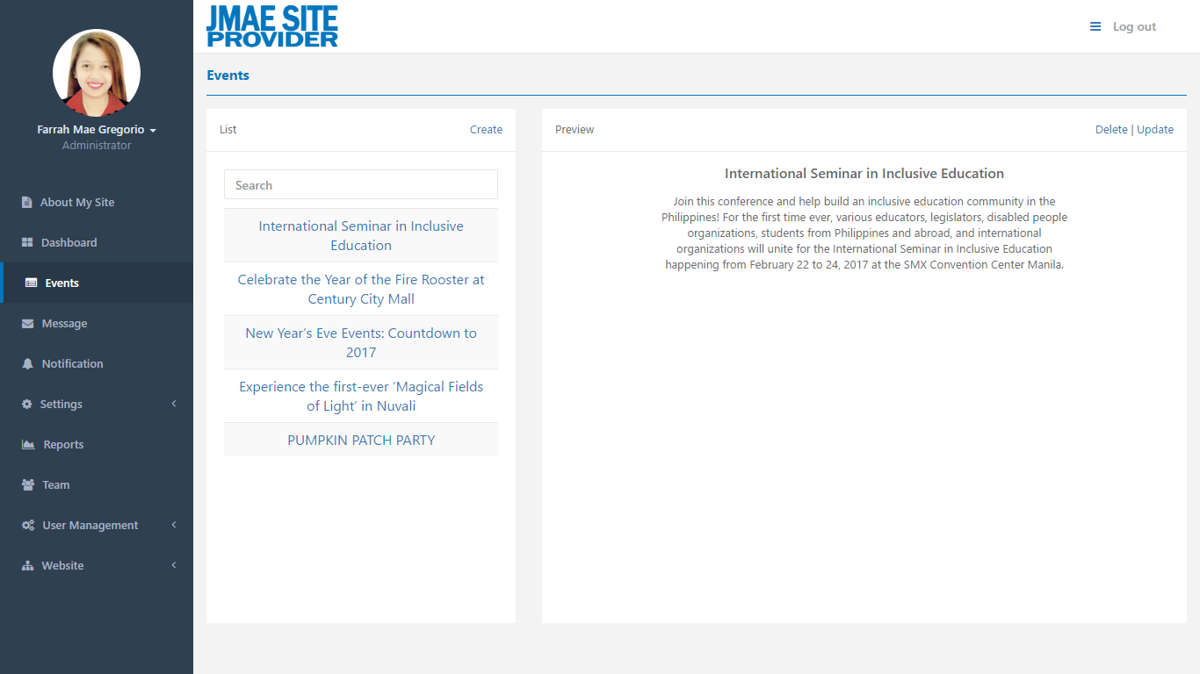

*Figure 6.27: Administrator – Events*

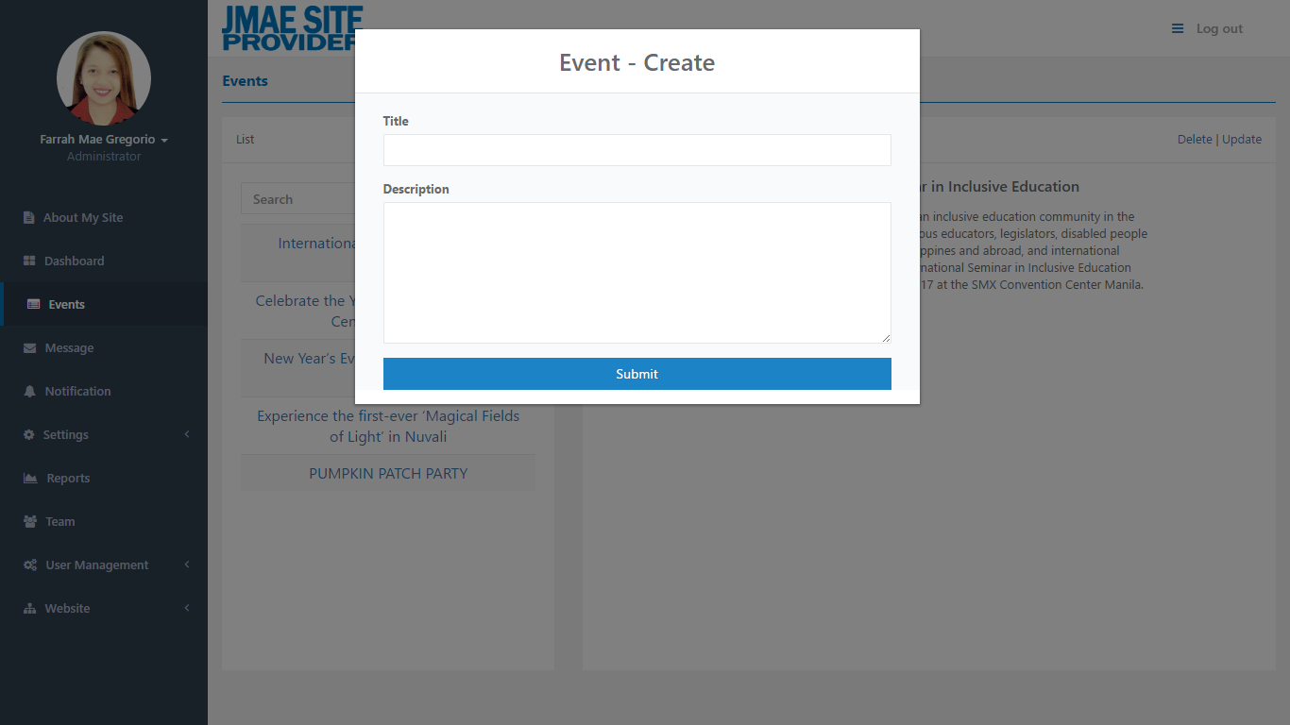

*Figure 6.28: Administrator – Events*

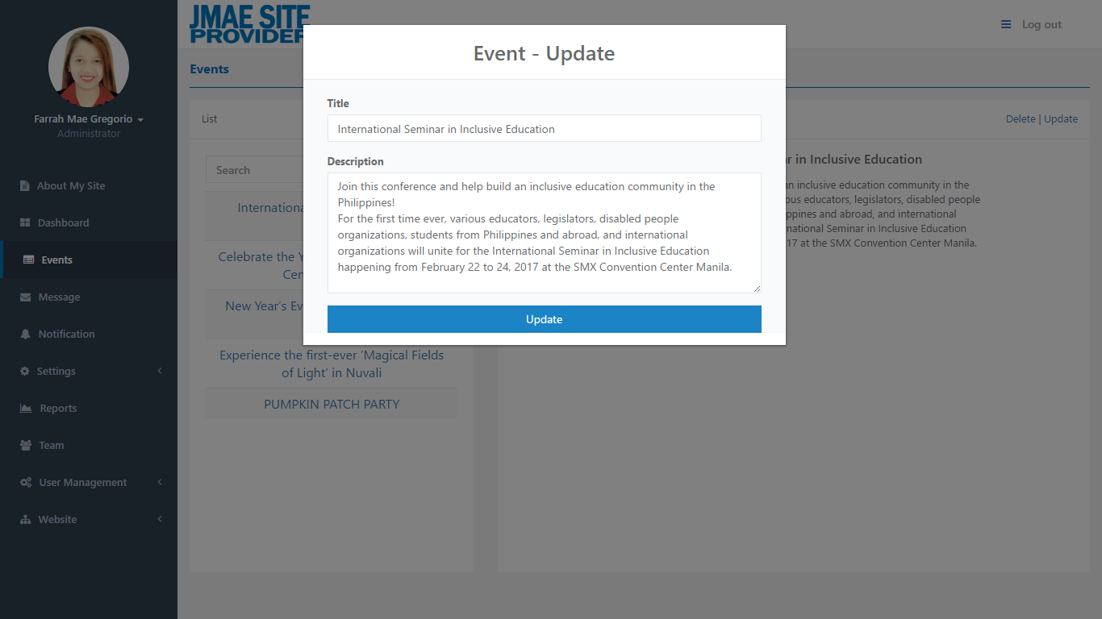

*Figure 6.29: Administrator – Events*

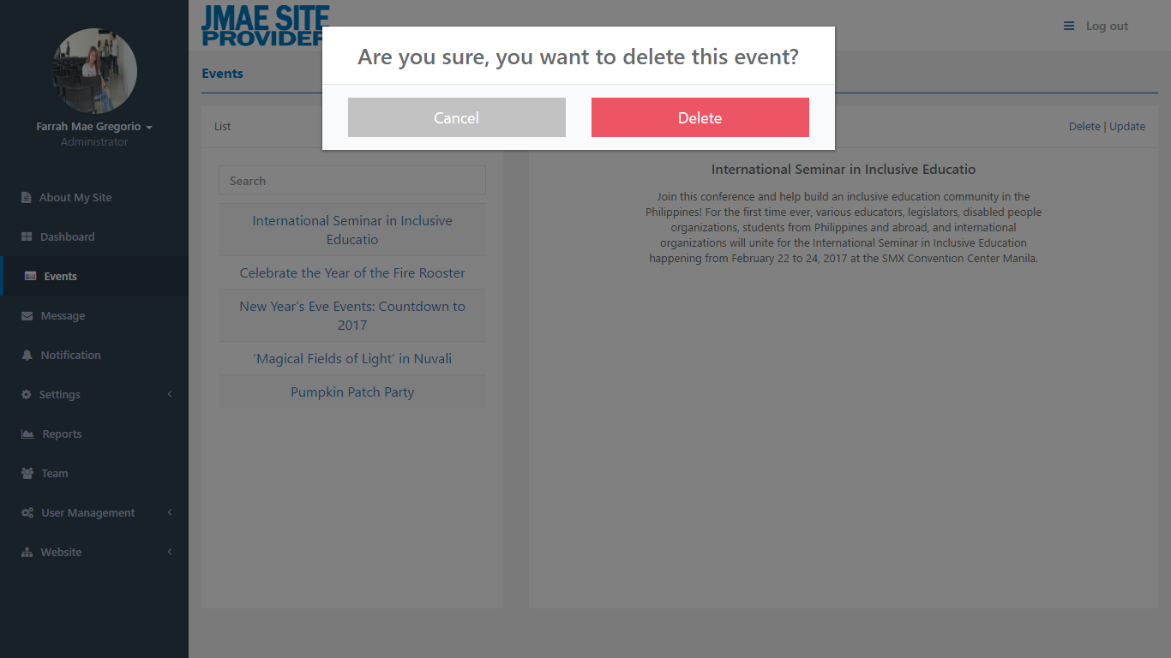

*Figure 6.30: Administrator – Events*

* In Events, you can see the list of events that already posted to the site.
* Also, you can update and delete the selected event.

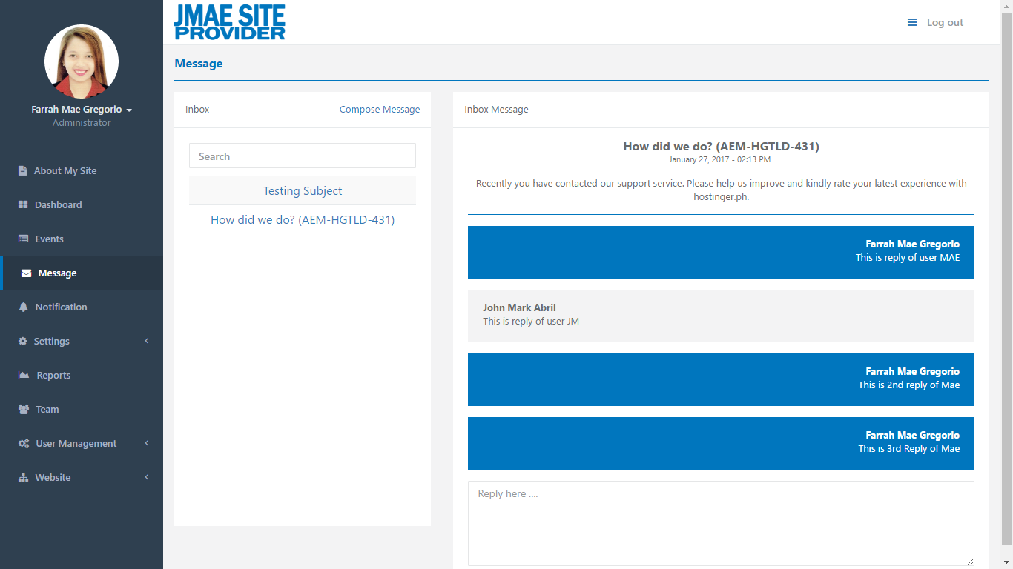

*Figure 6.31: Administrator – Message*

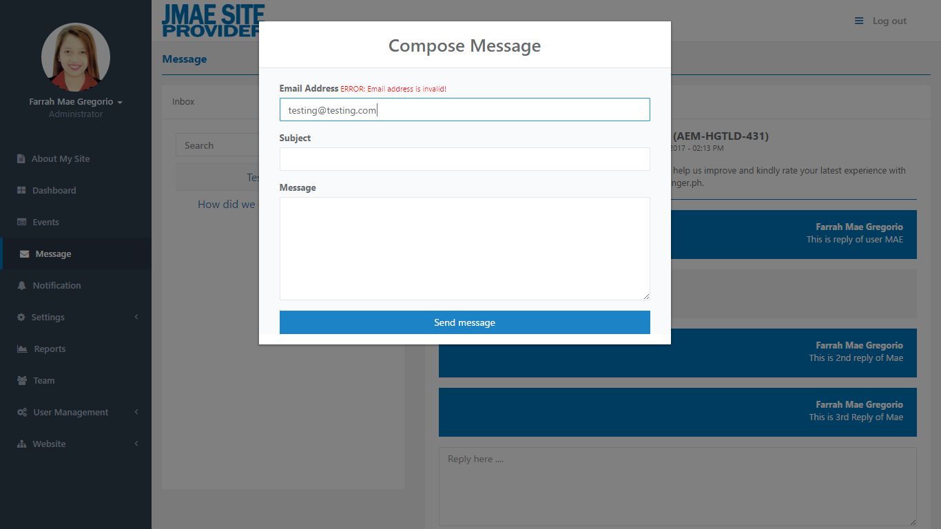

*Figure 6.32: Administrator – Message*

* In Message, you can see the list of message that sent to you.
* If you want to see the conversation just click the title of message which is located at left side. The conversation show on the right side.
* Also, you can compose the message but it can only send if the email is registered to JMAE Site Provider.

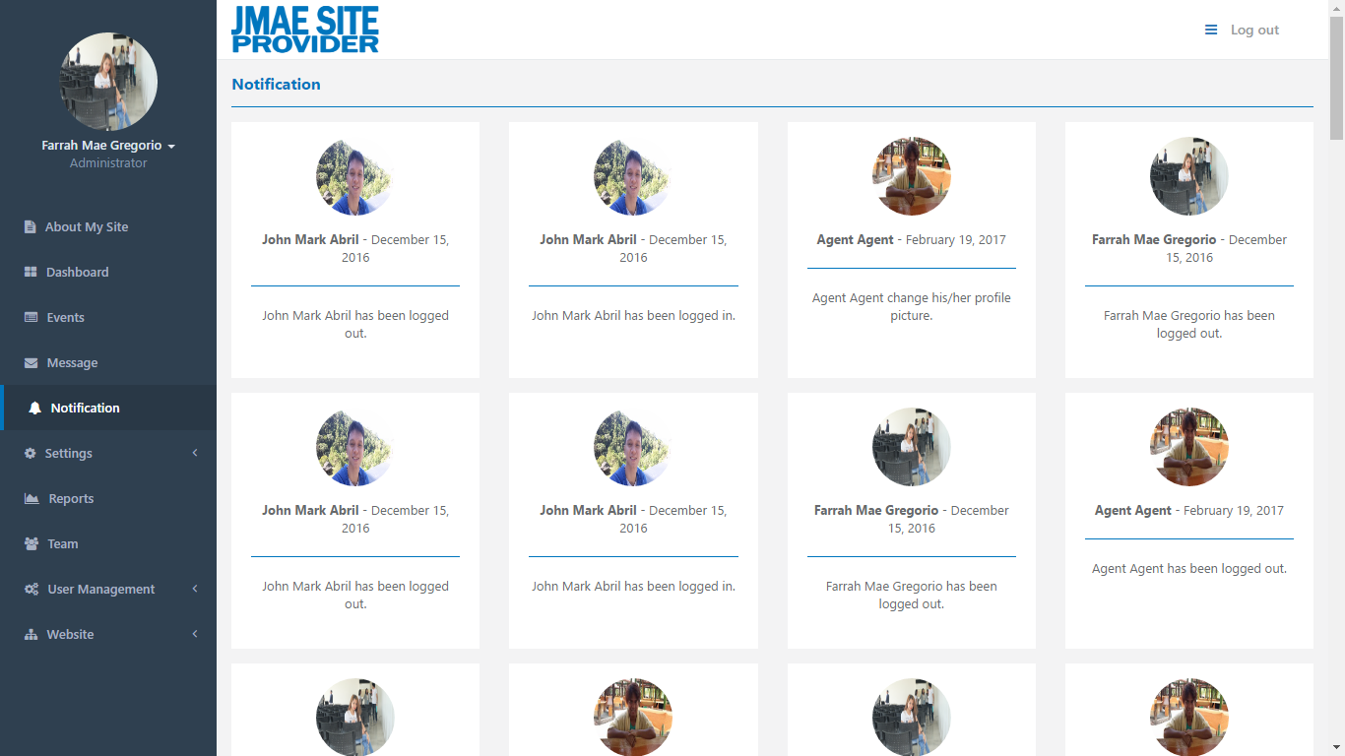

*Figure 6.33: Administrator – Notification*

* In Notification, you can notice the updates about the user activity.

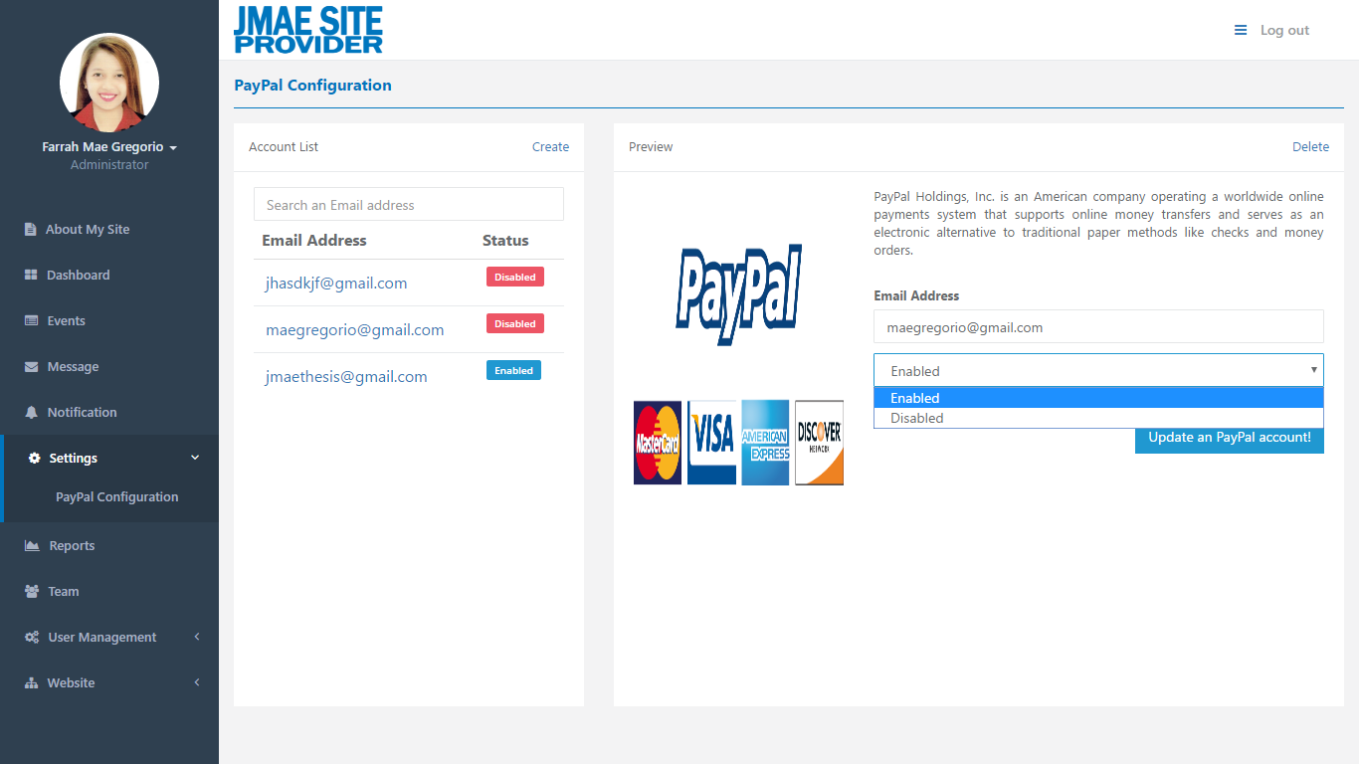

*Figure 6.34: Administrator – Settings*

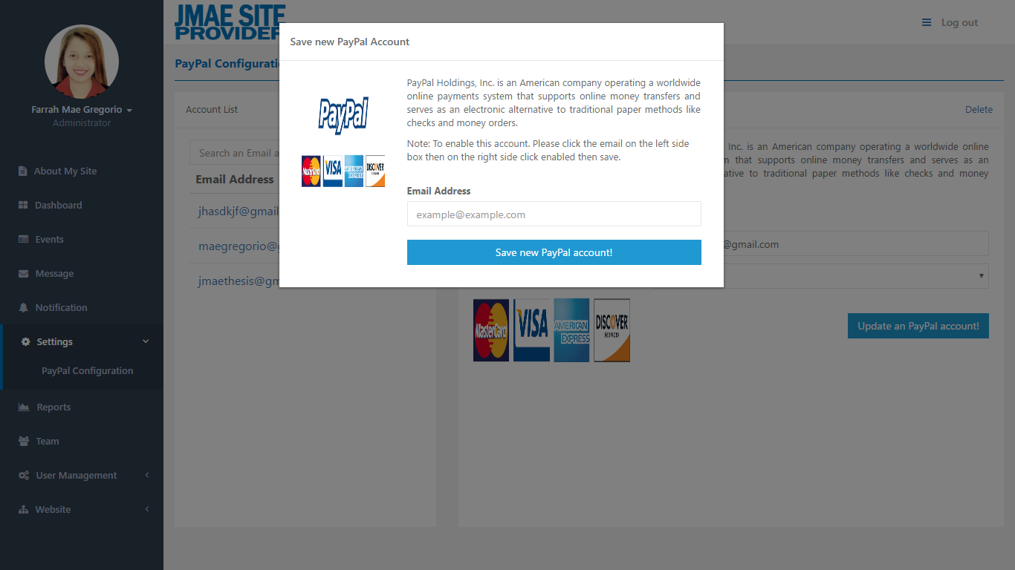

*Figure 6.35: Administrator – Settings*

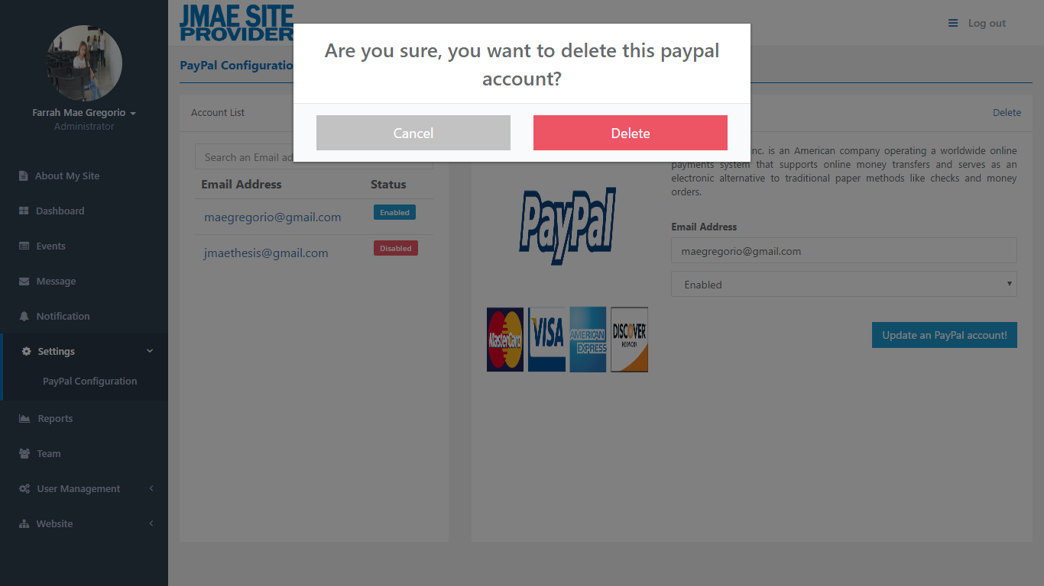

*Figure 6.36: Administrator – Settings*

* In Settings, there is a PayPal Configuration. The PayPal Configuration it contains of the list of PayPal account. You can choose only one account that the JMAE Site Provider use.
* If you want to enable or disable the account just simple click the PayPal Account located at left side, and at the right side click enable/disabled and Update an PayPal Account.
* Also, you can create and delete a PayPal account.

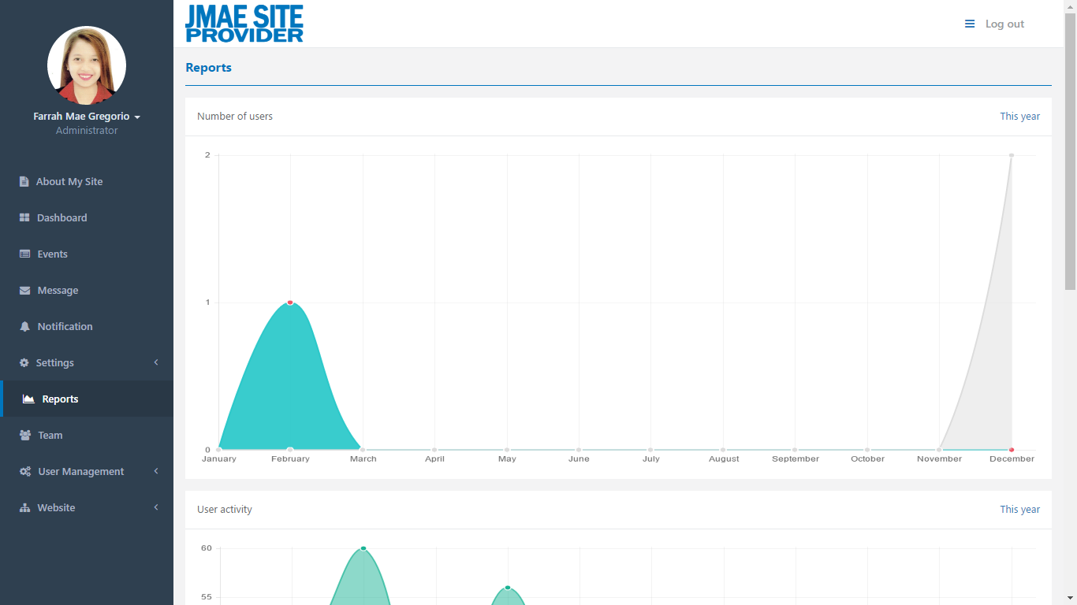

*Figure 6.37: Administrator – Reports*

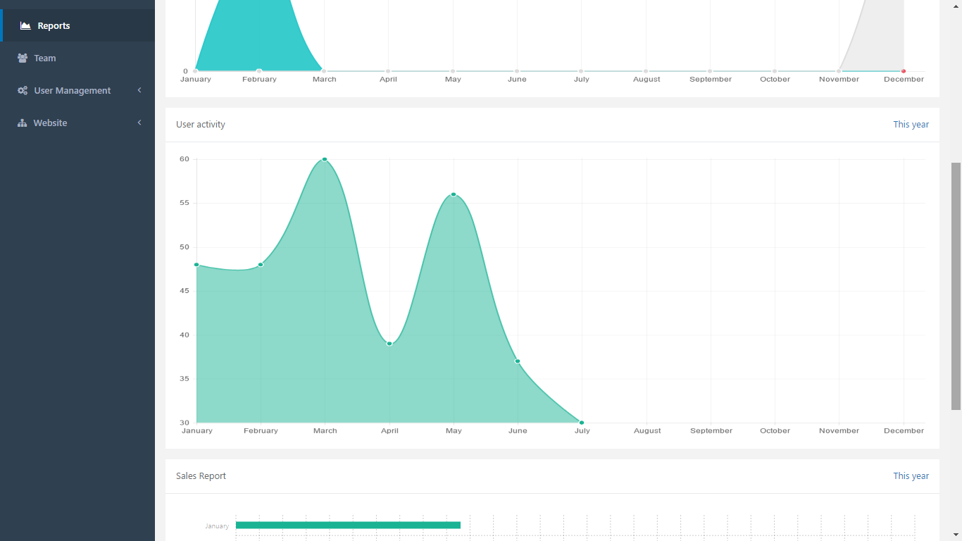

*Figure 6.38: Administrator – Reports*

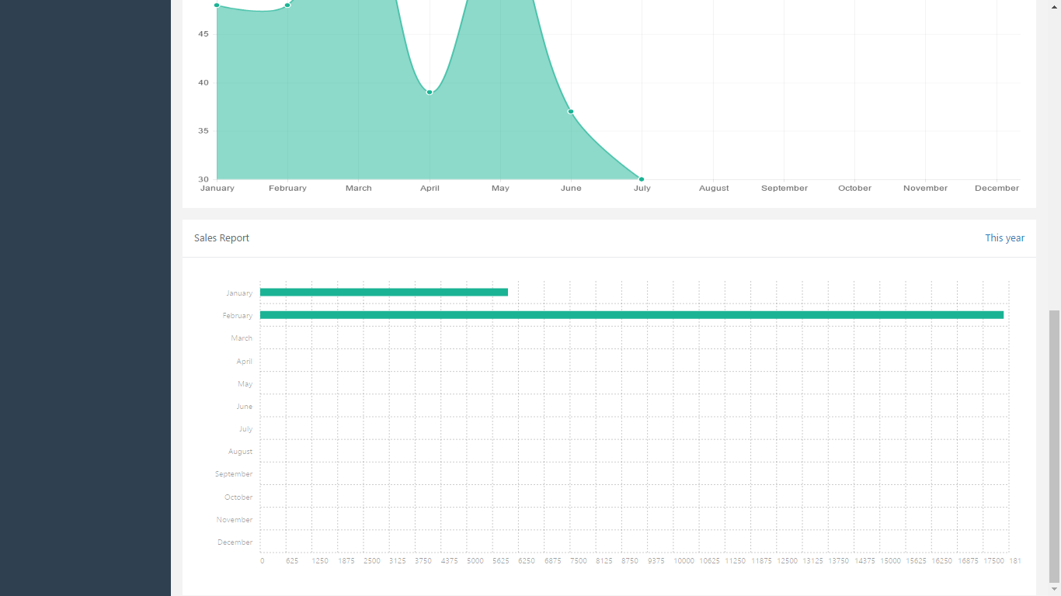

*Figure 6.39: Administrator – Reports*

* In Reports, it displays the report of Number of users, and User activity of the current year in graphical form for you to easy to understand.

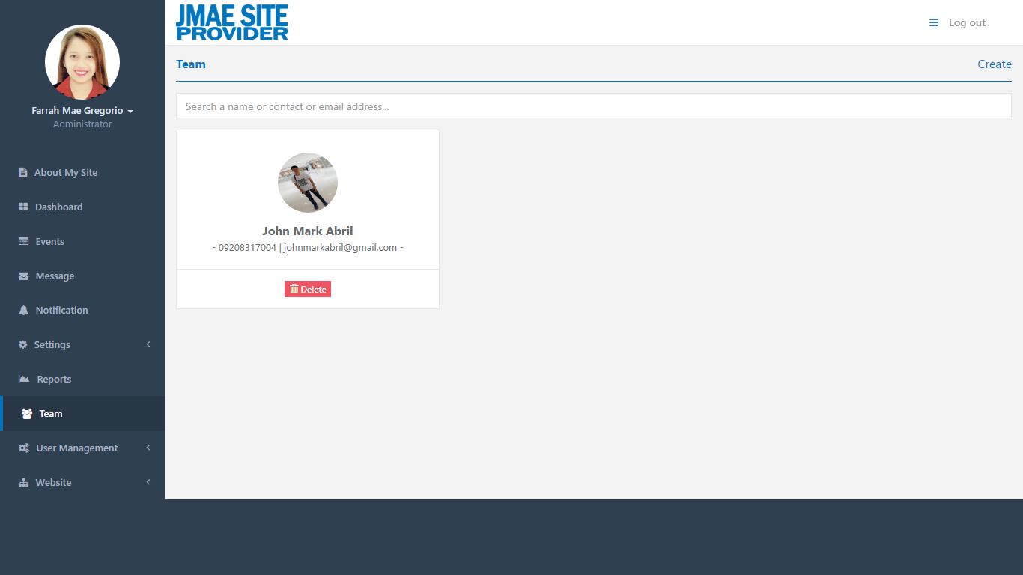

*Figure 6.40: Administrator – Team*

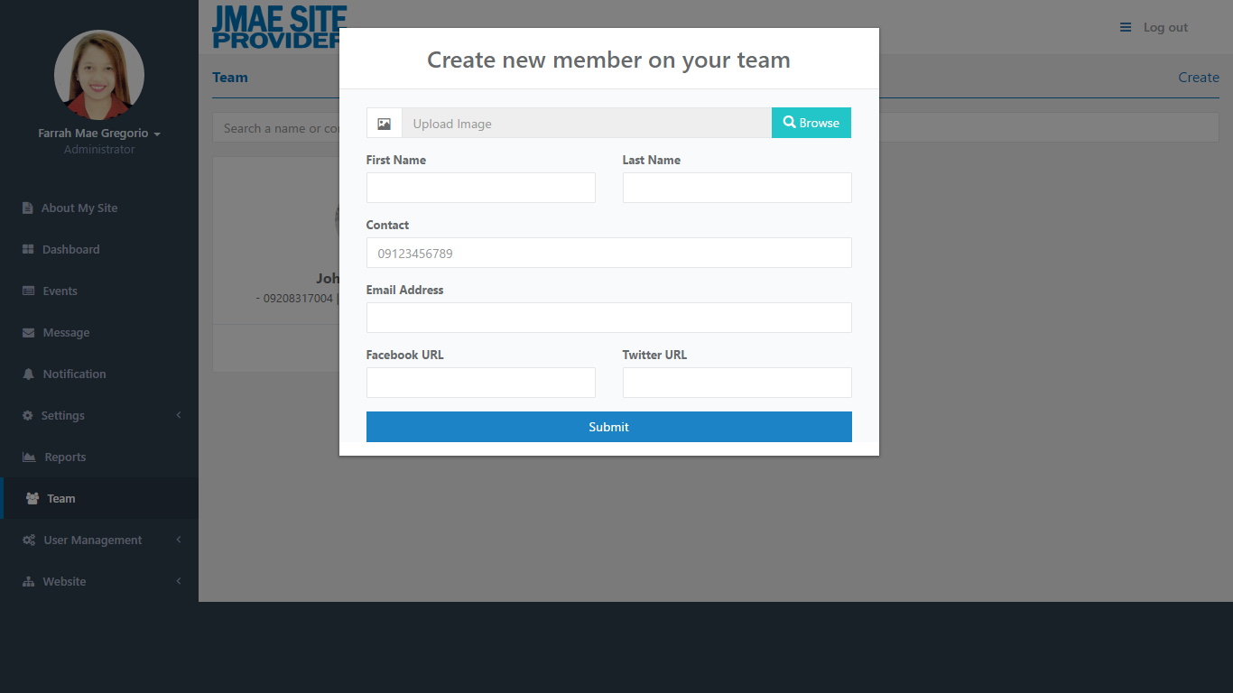

*Figure 6.41: Administrator – Team*

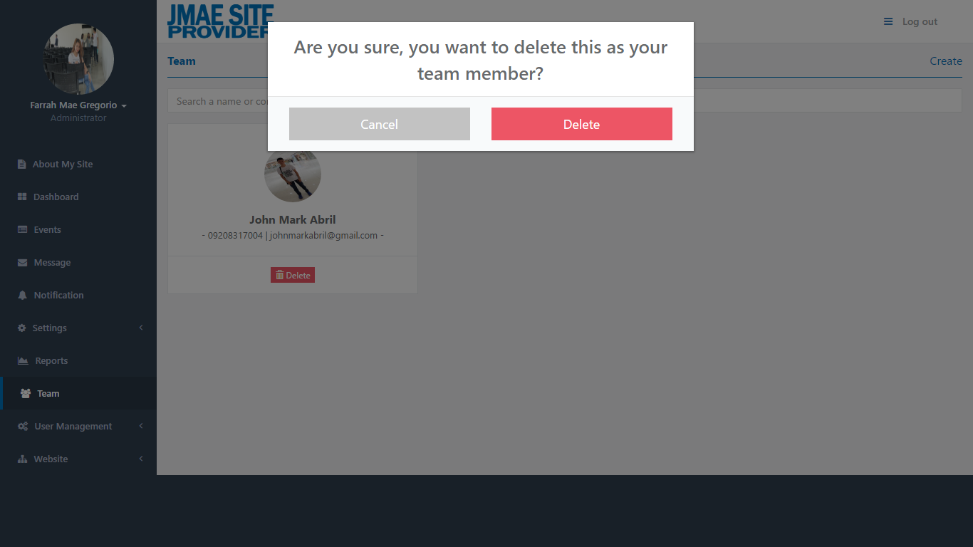

*Figure 6.42: Administrator – Team*

* In Team, you can see the team of this JMAE Site Provider.
* Also, you can create and delete a member of your team.

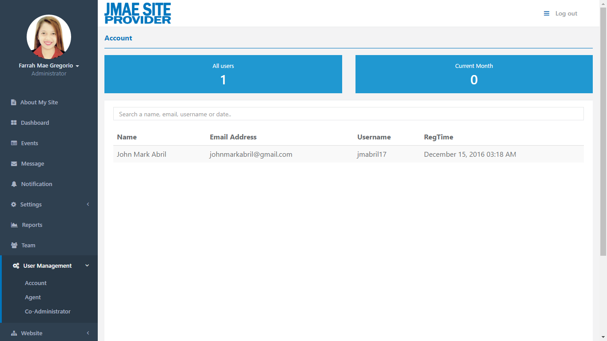

*Figure 6.43: Administrator – User Management – Account*

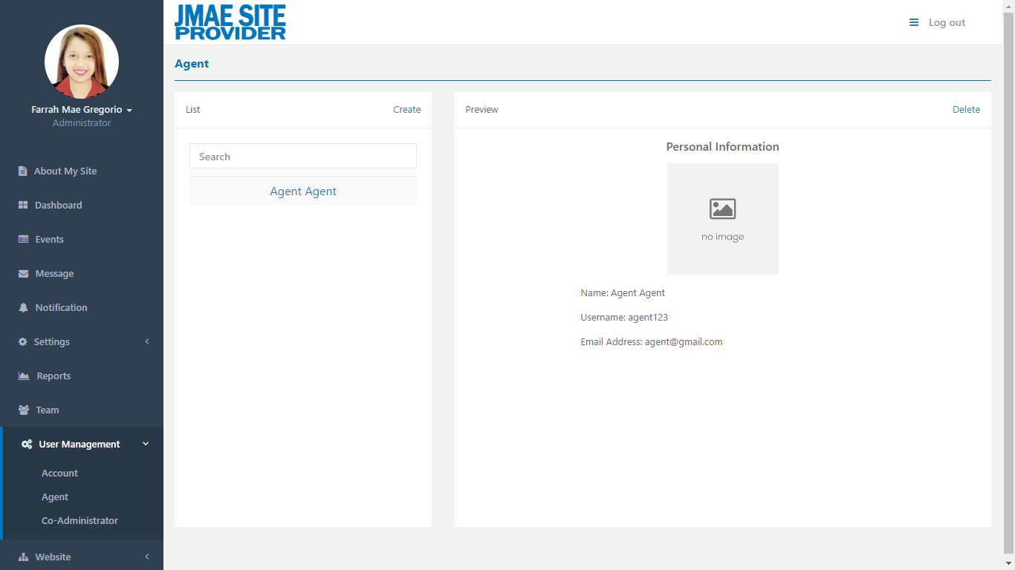

*Figure 6.44: Administrator – User Management – Agent*

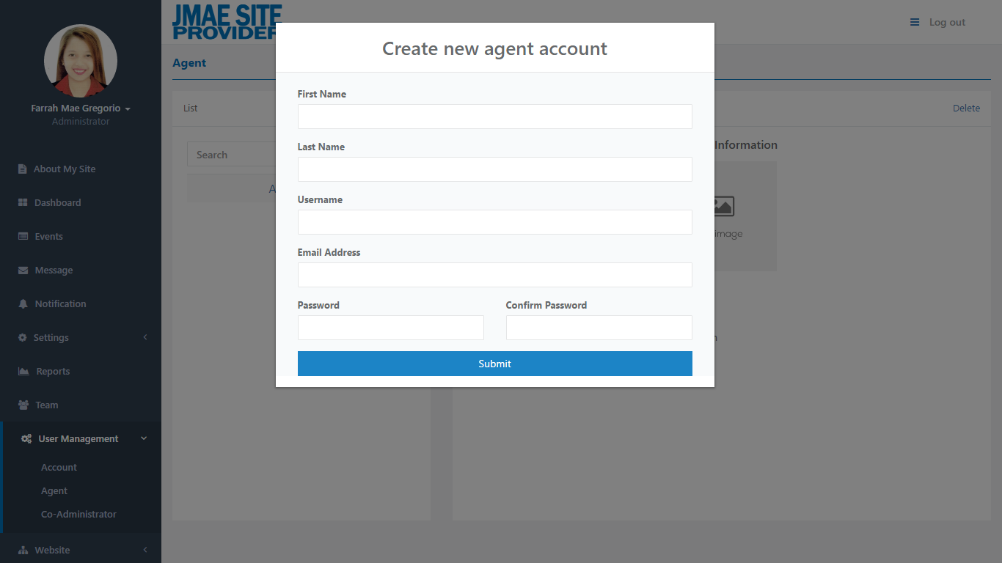

*Figure 6.45: Administrator – User Management – Agent*

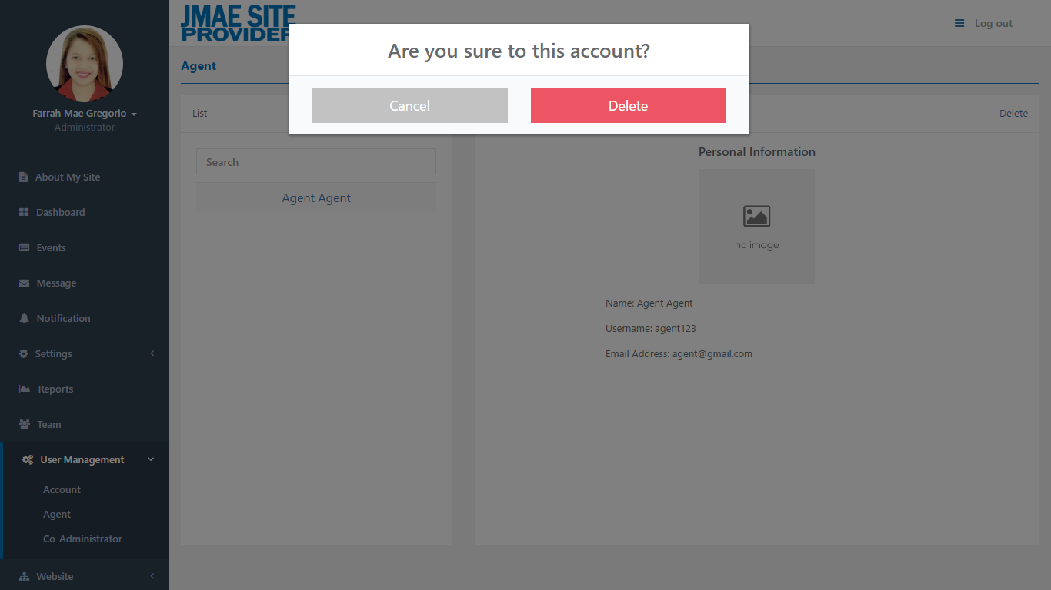

*Figure 6.46: Administrator – User Management – Agent*

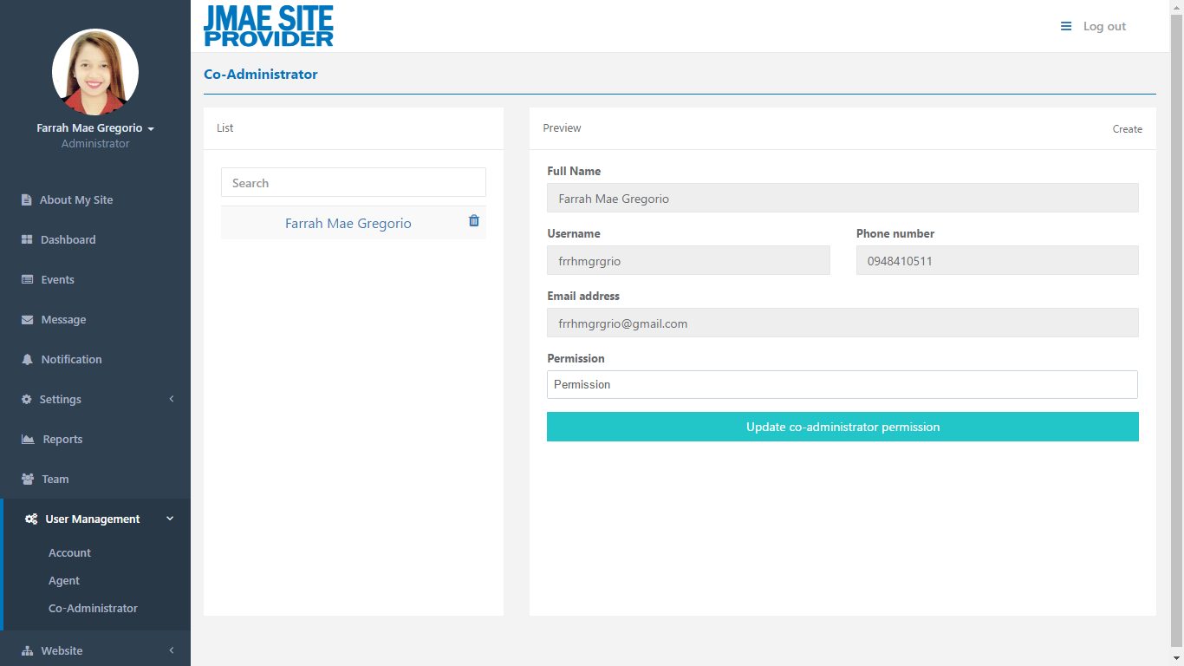

*Figure 6.47: Administrator – User Management – Co-Administrator*

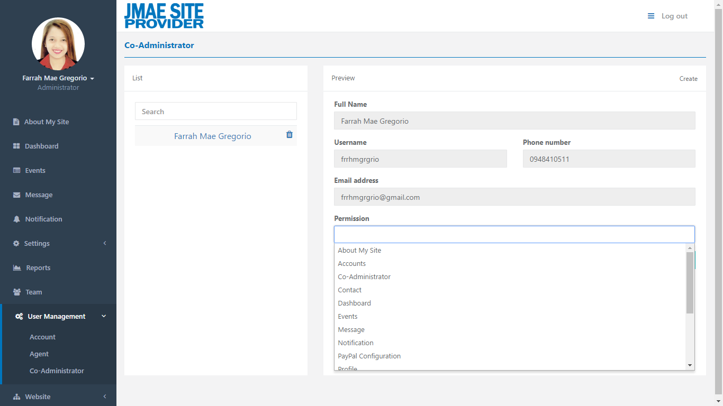

*Figure 6.48: Administrator – User Management – Co-Administrator*

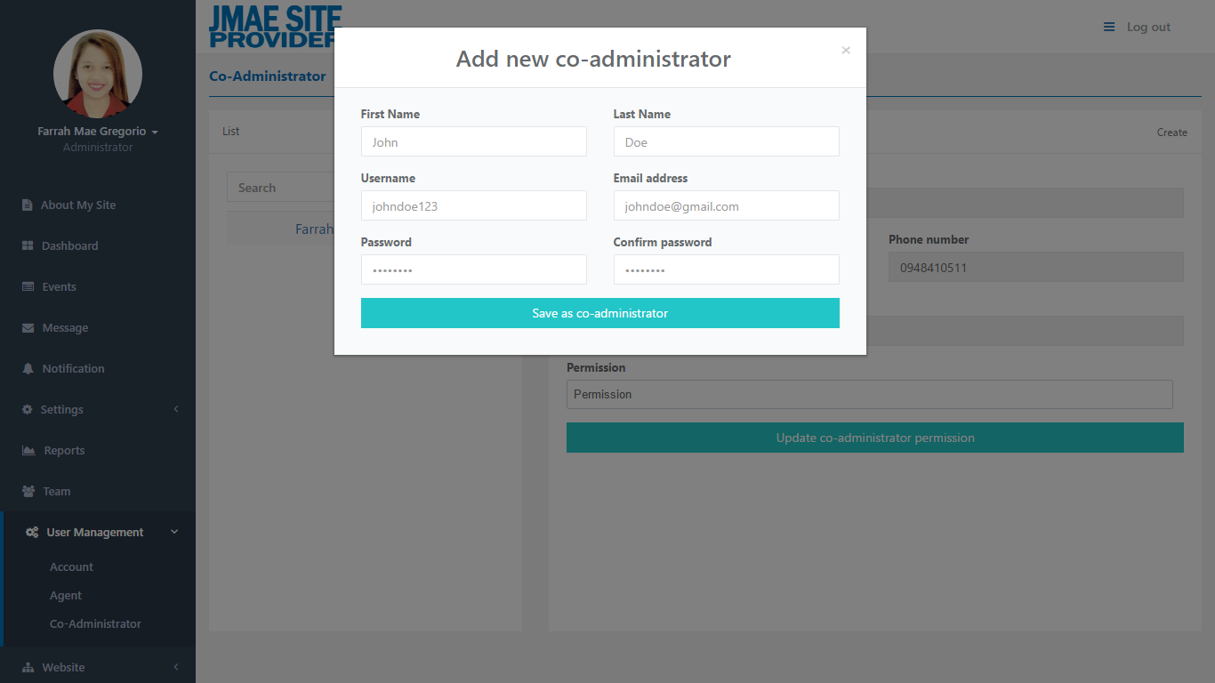

*Figure 6.49: Administrator – User Management – Co-Administrator*

* In User Management, there are sub categories: Account, Agent, Co-Administrator.
* In Account, you can see the total of all user account and the total user account for current month. At below, the user accounts are listed and you can search it.
* In Agent, you can see the list of agent account at the left side. The preview of the content of agent account selected is located at the right side. Also, you can create or delete an agent account.
* In Co-administrator, at the left side you can see the list of co-administrator account, and at the right side you can see the preview of the content of co-administrator account and update the permission. Also, you can create a co-administrator account.

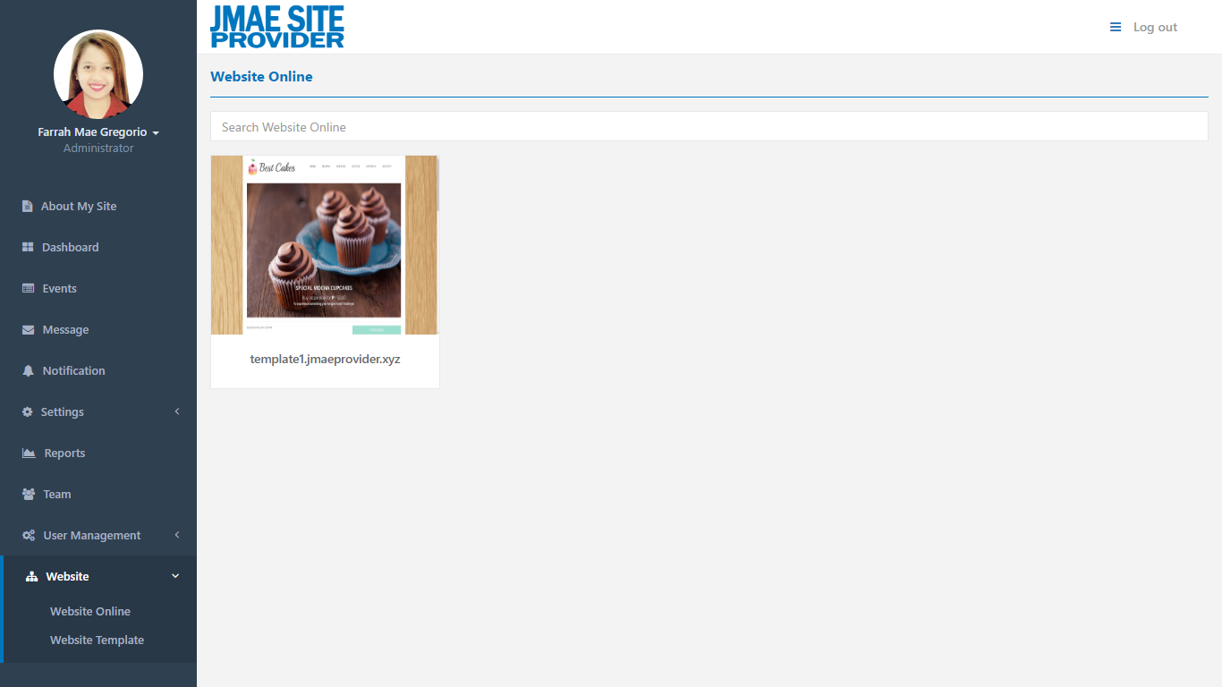

*Figure 6.50: Administrator – Website – Website Online*

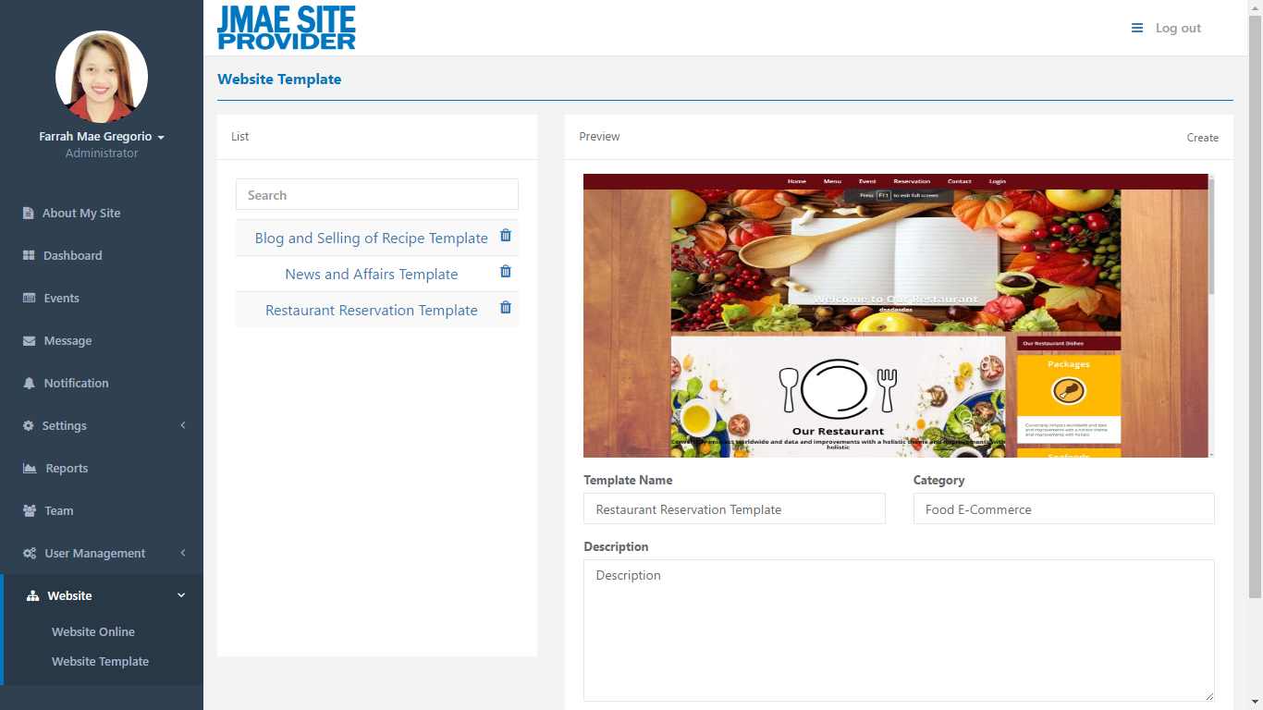

*Figure 6.51: Administrator – Website – Website Template*

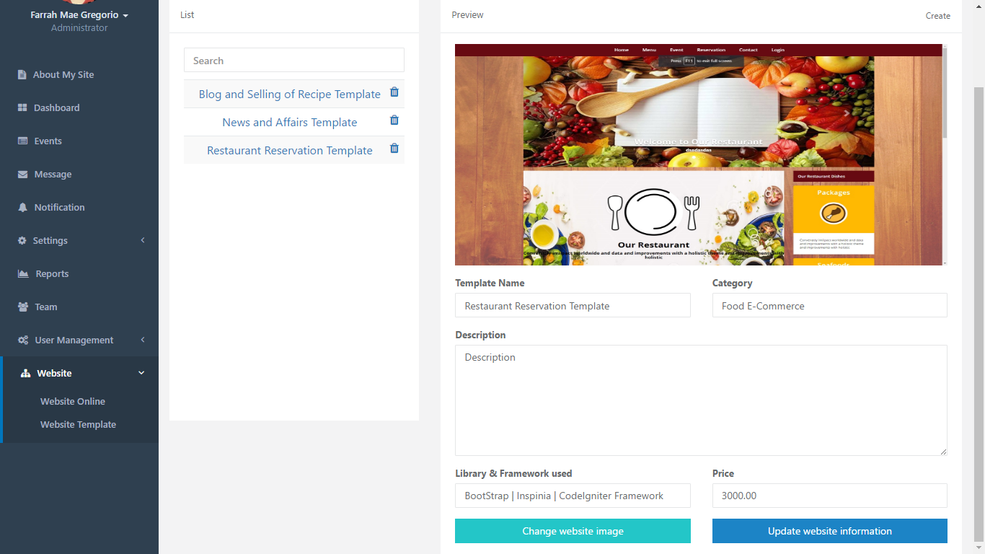

*Figure 6.52: Administrator – Website – Website Template*

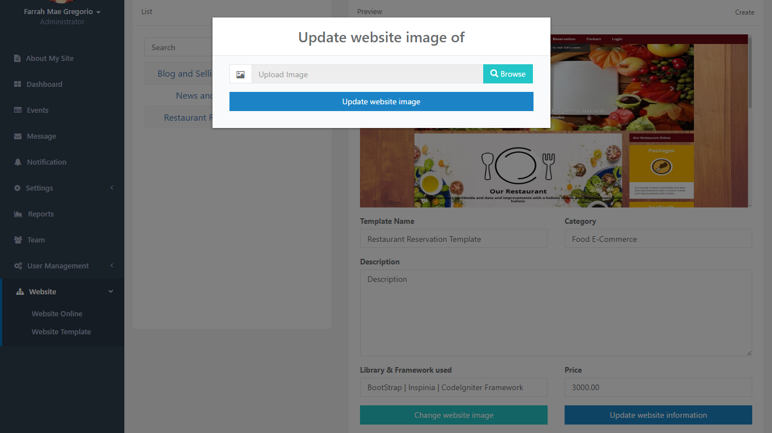

*Figure 6.53: Administrator – Website – Website Template*

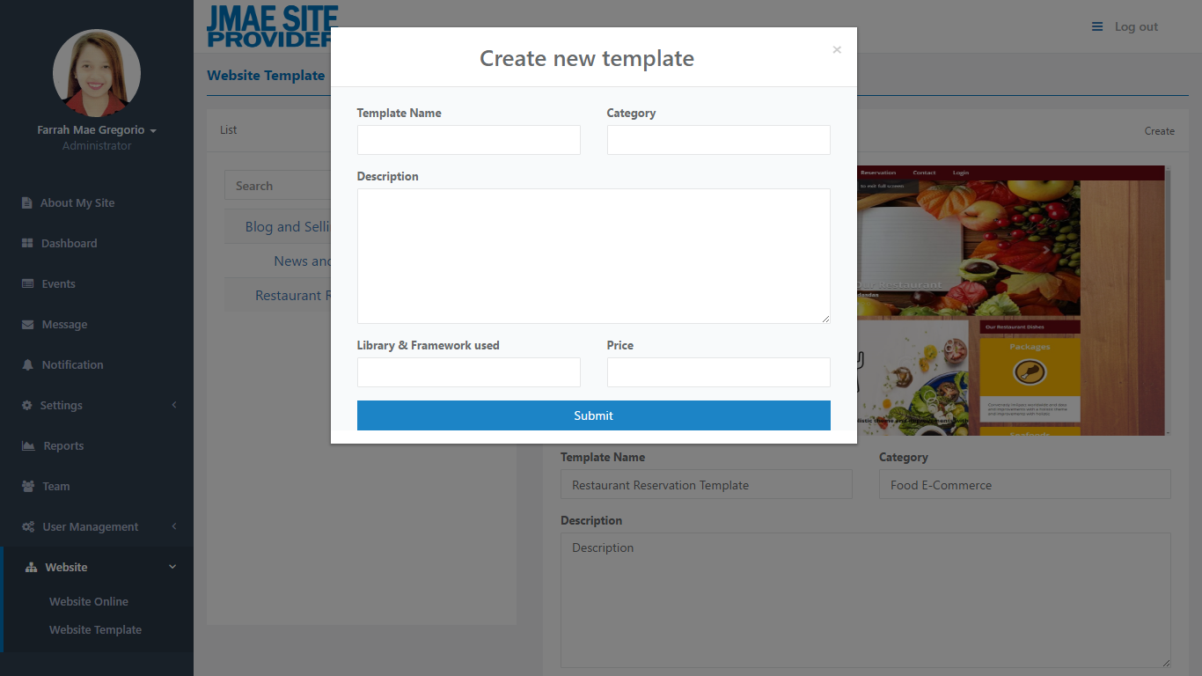

*Figure 6.54: Administrator – Website – Website Template*

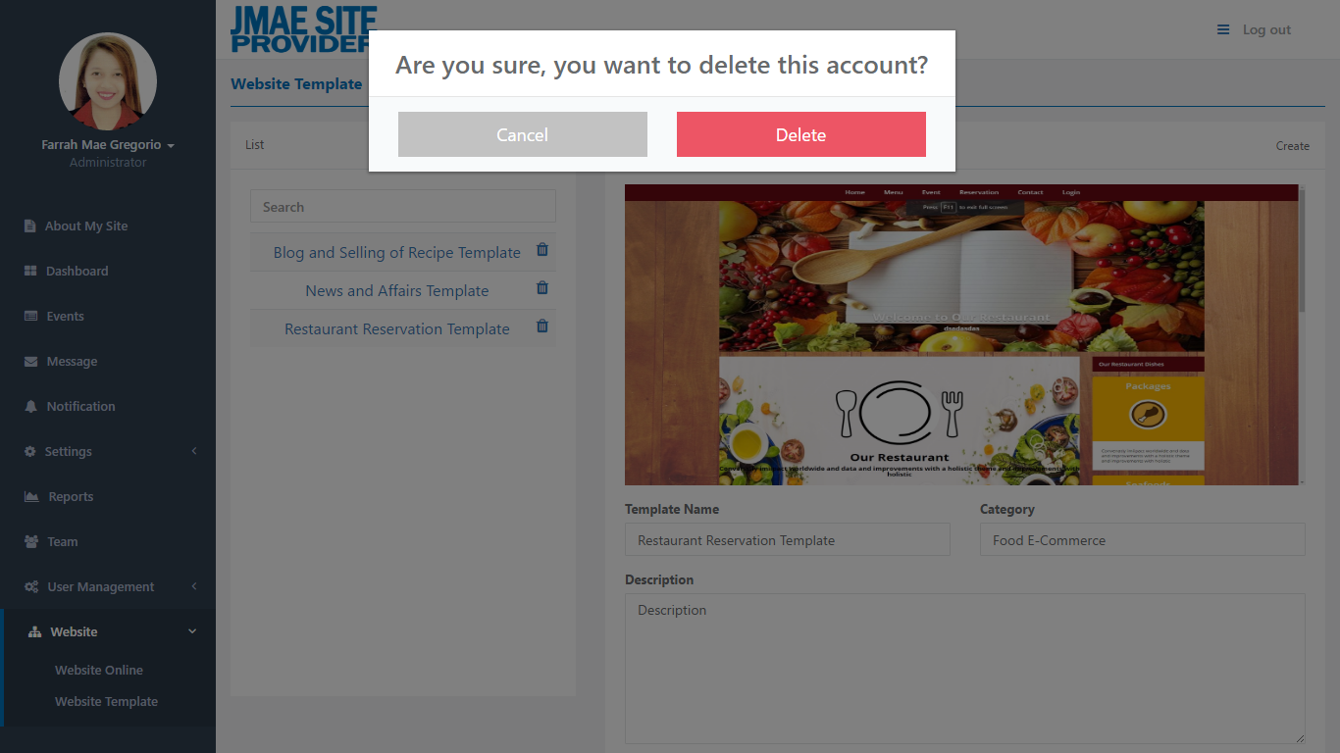

*Figure 6.55: Administrator – Website – Website Template*

* In Website, there is a sub categories: Website Online and Website Template.
* In Website Online, you can see the list of template/s that already rented by the client.
* In Website Template, you can see the list of template that available for rented, if you want to preview the content just simple click the template name at the left side and the preview is located at the rights side.
* If you want to update the image of template selected just click the  and if you want to update the content just click the .
* Also, you can create and delete a website template.

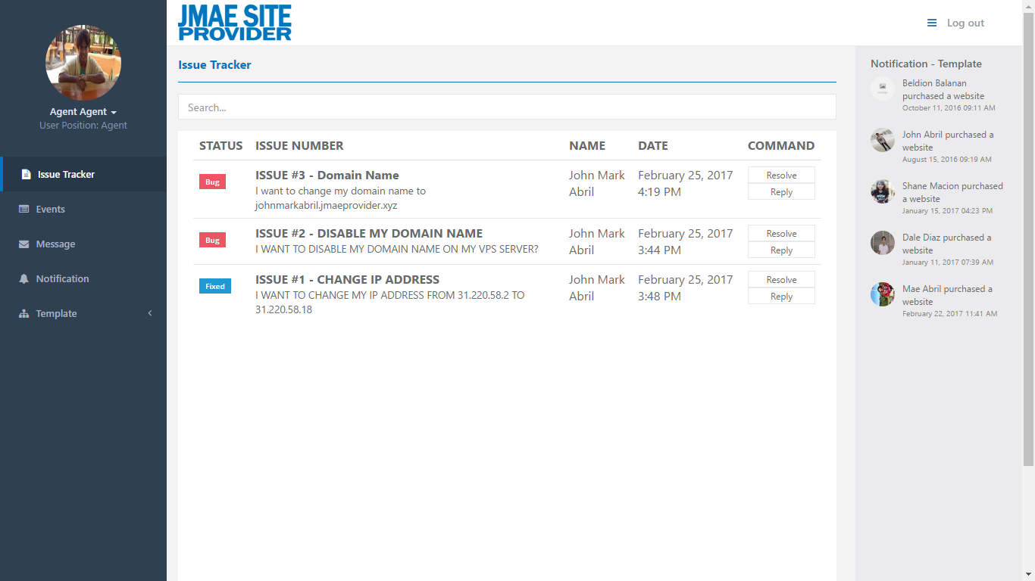

*Figure 6.56: Agent – Issue Tracker*

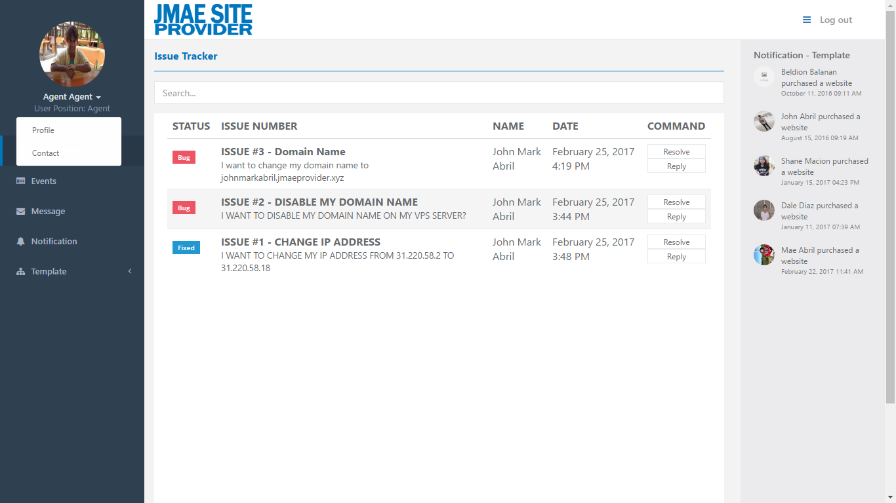

*Figure 6.57: Agent – Issue Tracker*

* If you log in as agent, you can see in your navigation on the left side, there are twelve (7) categories: The Profile, Contact, Issue Tracker, Events, Message, Notification, and Template.
* Issue tracker, it is the same function in administrator.
* The notification at the right side it is fixed whenever you open different categories it is still there.

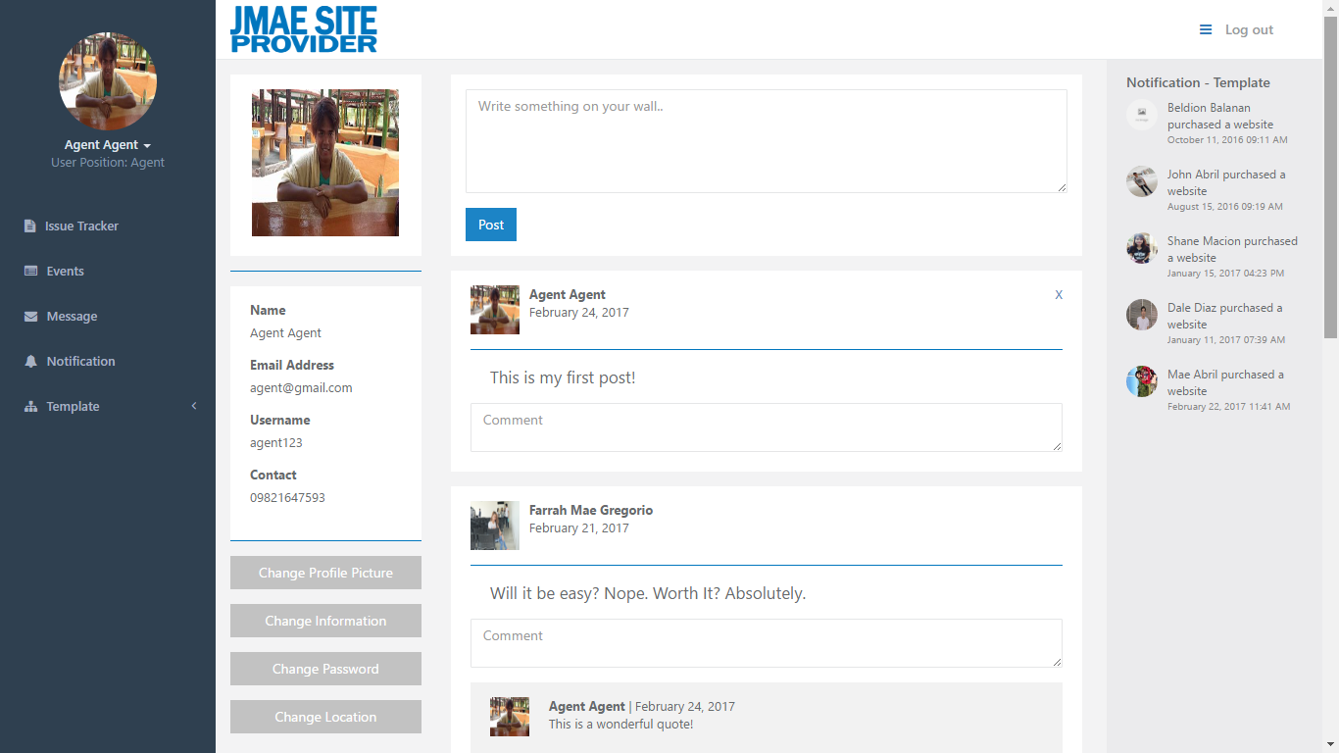

*Figure 6.58: Agent – Profile*

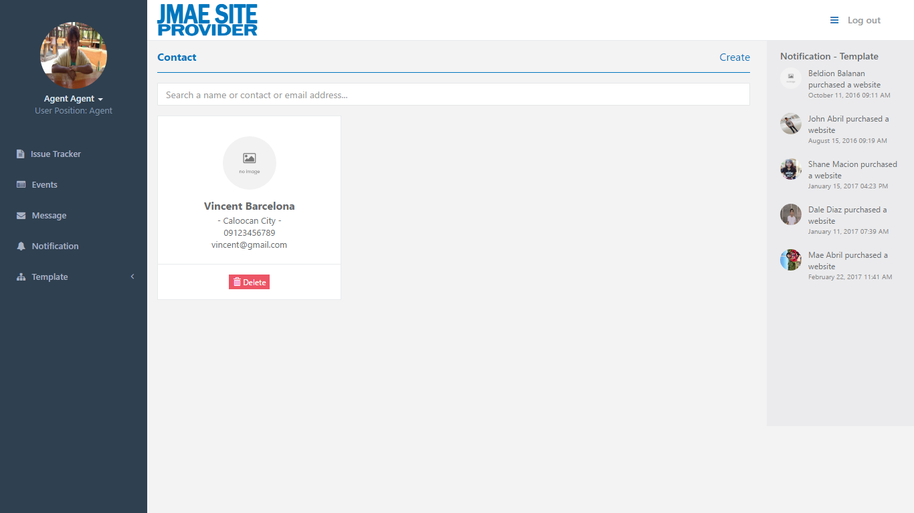

*Figure 6.59: Agent – Contact*

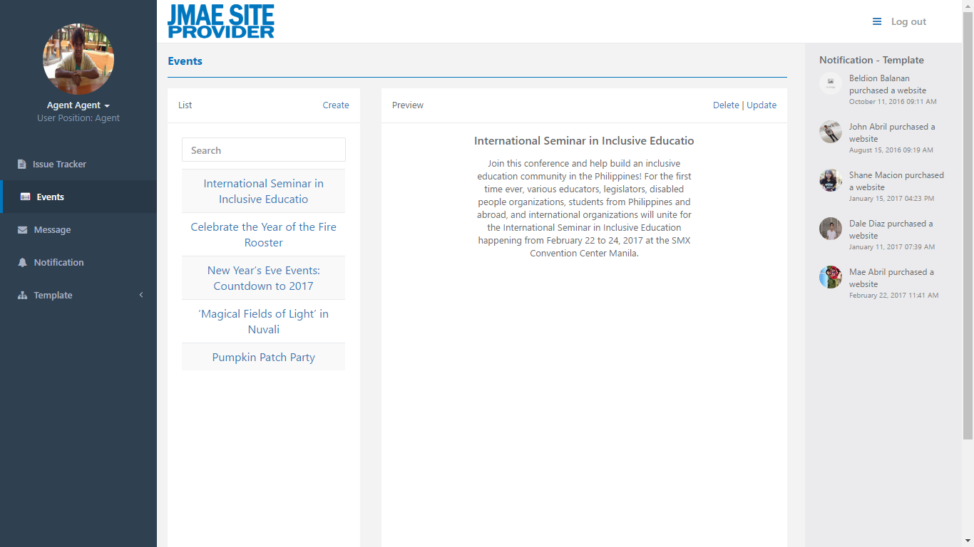

*Figure 6.60: Agent – Events*

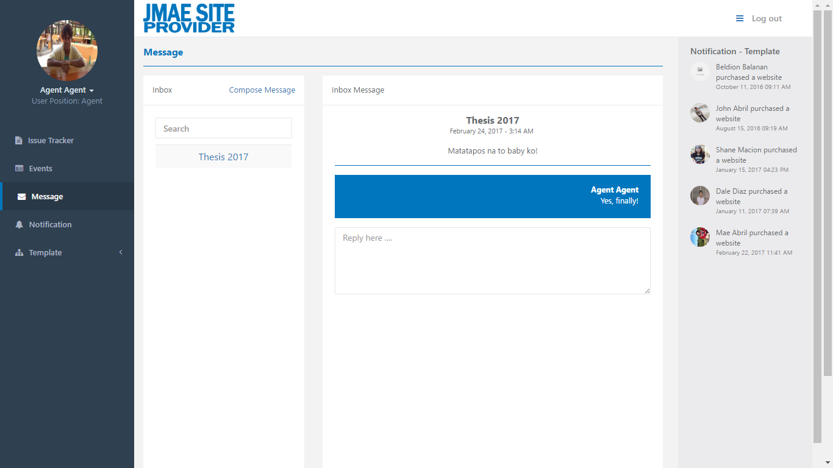

*Figure 6.61: Agent – Message*

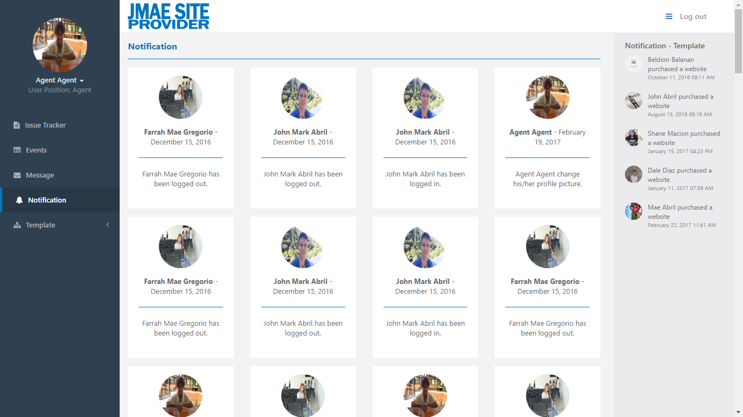

*Figure 6.62: Agent – Notification*

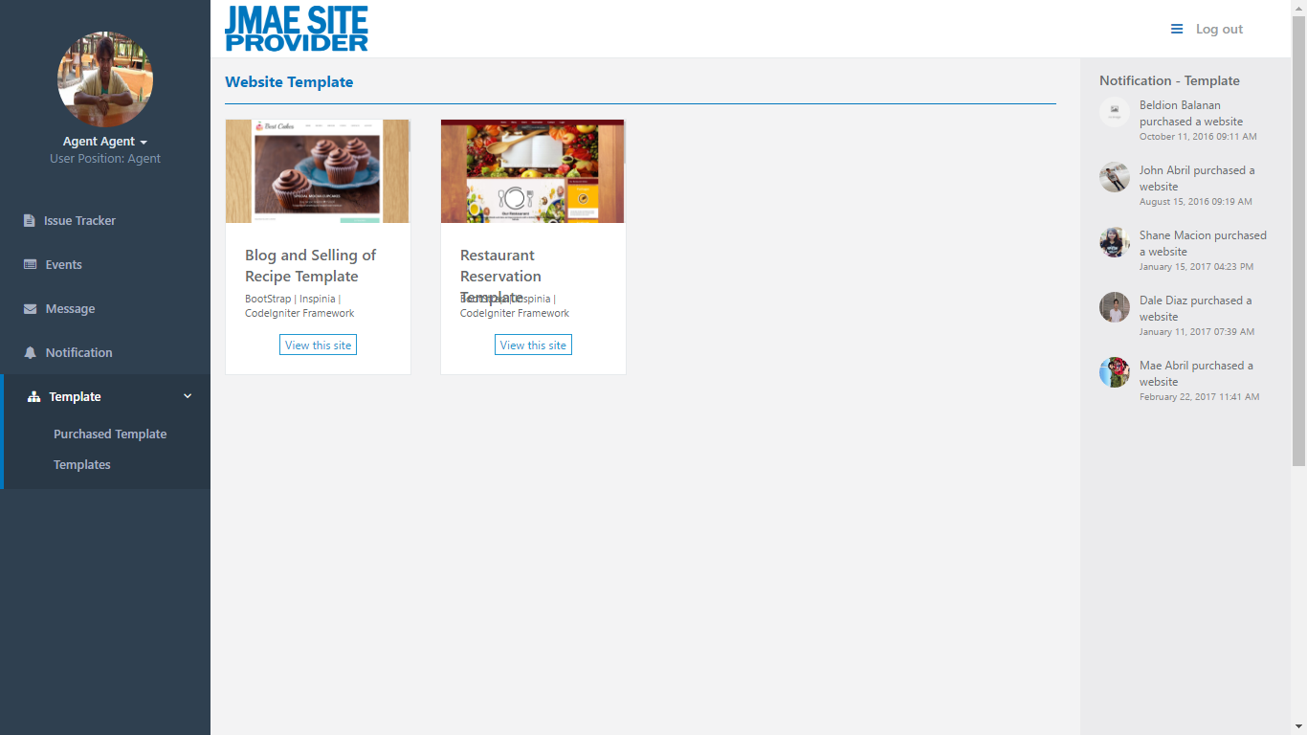

*Figure 6.63: Agent – Website – Purchased Template*

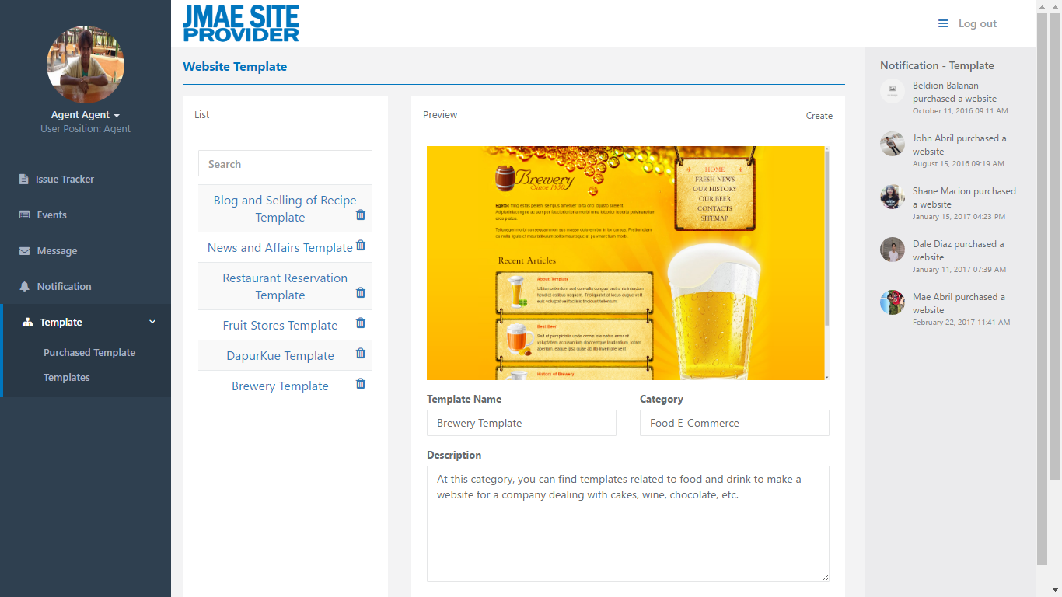

*Figure 6.64: Agent – Website – Template*

* These are still the same function in administrator.

**Appendix E: Project Cost**

|  |  |
| --- | --- |
| ITEM | COST |
| Web Domain | ₱ 12.50 |
| Web Hosting | ₱ 1,462.50 |
| Web Server | ₱ 429.00 |
| Total | ₱ 1,904.00 |

The approximated consumption for the proposed system is Web Domain, Web Hosting, and Web Server. The Web Domain cost of ₱ 12.50 for every twelve (12) months, Web Hosting cost of ₱1,462.50 for every six (6) months, and Web Server cost of ₱429.00 for every twelve (12) months, with the total of ₱1,904.00.

**Appendix F: Program Code**

**Appendix G: Transcript of Interview**

**Appendix H: Other Supporting Document**

**Appendix I: Evaluation Form**

**Appendix J: Disclaimer**

**Appendix K: Curriculum Vitae of Researchers**

**JOHN MARK CASTOR ABRIL**

655 D. Guillermo St. Gagalangin Tondo, Manila

09208317004

johnmarkabril@gmail.com

***http://johnmarkabril.netai.net/***

|  |  |  |  |
| --- | --- | --- | --- |
| **PERSONAL DETAILS** | | | |
| *Gender:*  *Date of Birth: Nationality: Height:* | Male  September 17, 1997 Filipino  5’ 5” | *Status:*  *Place of Birth: Languages: Weight:* | 19 years old  Pangasinan City  Filipino and English 100 lbs |

|  |  |
| --- | --- |
| **EDUCATION** |  |
| **Bachelor of Science in Information Technology**  Divine Mercy College Foundation, Inc. 129 University Avenue, Caloocan City   * *Graduating student*   **Secondary Education**  Florentino Torres High School  Juan Luna St., Gagalangin. Tondo, Manila   * *High School Diploma*   **Primary Education**  Francisco Benitez Elementary School  134 Solis St, Tondo, Manila, Metro Manila   * *Elementary Diploma* | **2013 – 2017**  **2009 – 2013**  **2002 - 2009** |

|  |  |
| --- | --- |
| **ACHIEVEMENTS** | |
| **Web Development: CCSS Exhibit**  Divine Mercy College Foundation, Inc. 129 University Avenue, Caloocan City   * *March 8, 2014*   **MoBot Race: CCSS Event**  Divine Mercy College Foundation, Inc. 129 University Avenue, Caloocan City   * *March 5, 2016* | **2nd Place**  **1st Place**  **y** | |

|  |  |
| --- | --- |
| **WORK EXPERIMENT** | |
| **On the Job Training**  Fourth Shift Global Inc.   * *April 11, 2016 – May 30, 2016* | **Web Developer** | |

**FARRAH MAE GREGORIO**

Blk 30 Lot 20 Phs 3 f1 A2 Kaunlaran Village

Dagat-dagatan Caloocan City

09484410511

frrhmgrgrio@gmail.com

|  |  |  |  |
| --- | --- | --- | --- |
| **PERSONAL DETAILS** | | | |
| *Gender:*  *Date of Birth: Nationality: Height:* | Female  October 11, 1996 Filipino  4’9” | *Status:*  *Place of Birth: Languages: Weight:* | Single  Roxas City  English and Filipino  71 lbs |

|  |  |
| --- | --- |
| **EDUCATION** |  |
| **Bachelor of Science in Information Technology**  Divine Mercy College Foundation, Inc. 129 University Avenue, Caloocan City   * *Graduating*   **Secondary Education**  Florentino Torres High School  Juan Luna St., Gagalangin. Tondo, Manila   * *High School Diploma*   **Primary Education**  Kaunlaran Elementary School  Tamban Street, Barangay 20, Caloocan City   * *Elementary Diploma* | **2013 – Present**  **2009 – 2013**  **2002 - 2009** |

|  |  |
| --- | --- |
| **ACHIEVEMENTS** | |
| **MoBot Race: CCSS Event**  Divine Mercy College Foundation, Inc. 129 University Avenue, Caloocan City   * *March 5, 2016*   **Programming Wizard: CCSS Event**  Divine Mercy College Foundation, Inc. 129 University Avenue, Caloocan City   * *September 24, 2016* | **1st Place**  **3rd Place**  **y** | |

|  |  |
| --- | --- |
| **WORK EXPERIMENT** | |
| **On the Job Training**  Fourth Shift Global Inc.   * *April 11, 2016 – May 30, 2016* | **Web Developer** | |